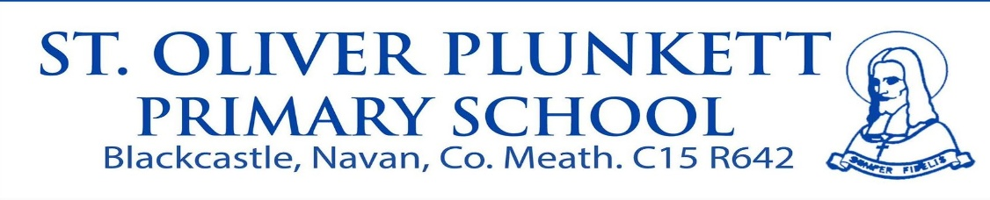
Annual Admission Notice
for the school year beginning September 2027
St Oliver Plunkett Primary School is a Primary School under the patronage of the Catholic Bishop of the Diocese of Meath.
Parents/Guardians wishing to enrol their child in Junior Infants for September 2027 in St Oliver Plunkett Primary School can apply from Thursday October 1st 2026 until Thursday October 22nd 2026.
Applications for Admission must be completed and returned to the school reaching the office no later than 12 noon on Thursday October 22nd 2026.
Offers of admission will be notified by Wednesday November 4th 2026.
Acceptance of the offer of admission must be received by the school by no later than 12 noon on Friday November 13th 2026.
The application form for admission and the admissions policy of this school can be found on our website www.stoliverplunkettnsnavan.ie or by request at the school office from Thursday October 1st 2026.
This year the number of places being made available for Junior Infants 2024 will be 52
St Oliver Plunkett Primary School ASD unit has a separate admissions process. The Admissions policy for this Unit can be accessed on our website. The number of places being made available in the ASD unit in September 2027 will be 1.
In accordance with the Education (Admission to Schools) Act 2018 §66 (6), the above School may,
in order to facilitate the efficient admission of pupils, share all or some of the data on the Application
for Admission with other Schools in the Navan area and with the Navan Enrolment Monitoring Body.

Navan Schools under the patronage of the Catholic Bishop of Meath
St. Anne’s Loreto, St. Joseph’s Mercy, Scoil Mhuire, Scoil Bhríde Cannistown,
Gaelscoil Éanna, St. Oliver Plunkett, St. Paul’s, Scoil Naomh Eoin.

Navan Schools under the patronage of Educate Together:
Navan Educate Together National School

