**St Oliver Plunkett’s Primary School**

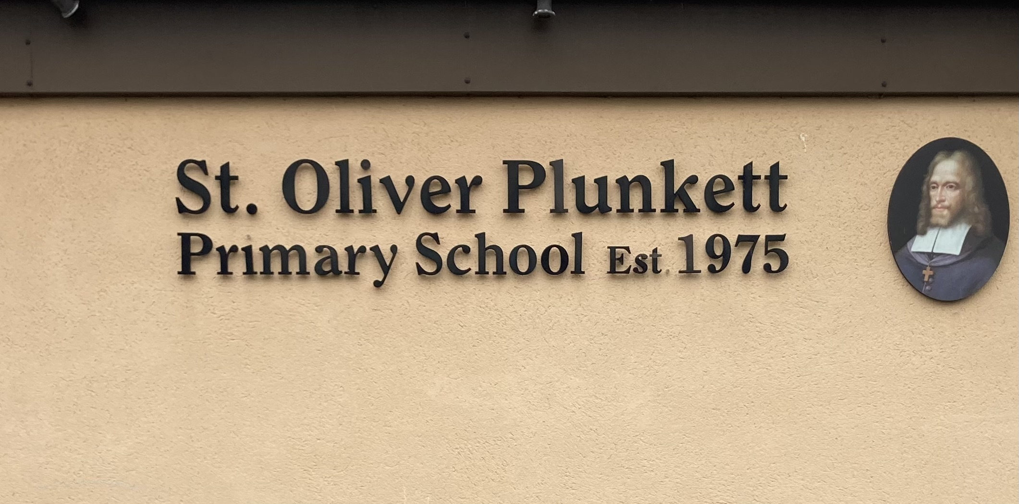

**Blackcastle, Navan, Co Meath**

**Roll number: 19476h**

[**www.stoliverplunkettsnavan.ie**](http://www.stoliverplunkettsnavan.ie)

**Twitter: @st_navan**

**Email:** [**stoliverns2@gmail.com**](mailto:stoliverns2@gmail.com)

**School Patron: Bishop of Meath**

**Dignity at Work Policy**

.

**St. Oliver’s Primary School Adopts the HSA Dignity in the Workplace Charter**

We commit ourselves to working together to maintain a workplace environment that encourages and supports the right to dignity at work. All who work here are expected to respect the right of each individual to dignity in their working life. All will be treated equally and respected for their individuality and diversity. Bullying in any form is not accepted by us and will not be tolerated. Our policies and procedures will underpin the principles and objectives of this Charter. All individuals, whether directly employed or contracted by us, have a duty and a responsibility to uphold this Dignity at Work Charter.

**1. Introduction**

As a school community, St Oliver Plunkett Primary School commits itself to working together to maintain a workplace environment that encourages and supports the right to dignity at work. All who work here and are members of the Board of Management and Parents Association are expected to respect the right to dignity in their working life. Every person will be treated equally and be respected for their individuality and diversity. Bullying or harassment in any form and from any party within and without the school is not accepted by us and will not be tolerated. Our policies and procedures will underpin the objectives of this charter.

**2. Rationale**

The Board of Management and the staff of St Oliver’s are committed to creating, maintaining and enhancing a positive work environment where work is done in an atmosphere of respect, collaboration, openness and equality.

**3. Relationship to the Characteristic Spirit of the School**

St Oliver Plunkett Primary School is a Catholic school in the Diocese of Meath under the patronage of Most Reverand Dr. Thomas Deenihan, Bishop of Meath.. The Board and the Staff promote respect for all and value each member of the school community. The school’s mission statement promotes the spirit of inclusiveness and the principles of equality.

**4. Aims of the Policy**

* To ensure that all employees of the Board of Management are treated with dignity and respect
* To prevent adult bullying and harassment in the workplace
* To formally recognise that all members of the school community have a part to play in modelling and promoting good behaviour
* To outline procedures that will be used to investigate and to deal with allegations of harassment, bullying and other inappropriate behaviour.

**5. Definitions**

For the purposes of this policy, the Board of Management has adopted the definition of bullying as outlined in the Code of Practice for Employers and Employees on the Prevention and Resolution of Workplace Bullying under the Safety, Health and Welfare at Work Act, 2005.

**5.1 What is Bullying?**

Bullying is defined as *‘Repeated inappropriate behaviour, direct or indirect, whether verbal, physical or otherwise, conducted by one or more persons against another or others, at the place of work and/or in the course of employment, which could reasonably be regarded as undermining the individual’s right to dignity at work.’*

**5.2 What Bullying is not.**

The following behaviour does not constitute bullying:

* The proper exercise of authority by managers
* Constructive and fair criticism of a staff member’s work performance or conduct provided in a reasonable manner or any appropriate action taken by managers under any specified policy
* It is the duty of managers to be open with staff about performance, attendance or general conduct. Poor performance, attendance and/or general conduct are dealt with under the Disciplinary Procedures.
* An isolated incident of the behaviour in this definition may be an affront to dignity but as a once off incident is not considered to be bullying.

**5.3 Examples of Bullying**

Behaviour that constitutes bullying may be physical, non-physical or verbal. Physical forms of bullying may include (list is not exhaustive):

* Shoving, jostling
* Interfering with personal property or work station

Non-physical and verbal forms of bullying may include (list is not exhaustive):

* Persistent unjustified criticism and sarcasm
* Shouting at staff in public and/or private
* Instantaneous rage, often over trivial issues
* Making it difficult for staff to have access to necessary information
* Unfair delegation of duties and responsibilities
* Private or public humiliation, deliberate exclusion/ostracism
* Repeated use of offensive language directed at an individual or individuals
* Personal insults, such as name-calling, sneering, continued and deliberate staring
* Repeated put-downs, offensive jokes
* Repeated verbal abuse
* Undermining a person’s role, dignity or respect e.g. removing areas of responsibility and imposing menial tasks
* Spreading malicious rumours
* Derogatory graffiti
* Threatening behaviour
* Aggressive behaviour by Principal or teaching colleague
* Unfair or unjust manipulation of one’s workload including timetable
* Higher levels of scrutiny of an individual staff members work by comparison with others
* Publishing material that is defamatory, abusive or offensive in relation to any staff member
* Publishing material online or on social media platforms or messaging apps that might reasonably be expected to have the effect of damaging the reputation or professional standing of a staff member

**5.4 What is harassment?**

Harassment (other than sexual harassment) is defined as ‘any form of unwanted conduct related to any of the discriminatory grounds covered by the Equality Acts 1998 to 2008:

* Civil status
* Family status
* Sexual orientation
* Religious belief (or none)
* Age
* Disability
* Race, nationality or ethnic or national origin
* Gender
* Membership of the Traveller community

Harassment is defined in the Acts as *‘any form of unwanted conduct related to any of these discriminatory grounds which has the purpose or effect of violating a person’s dignity and creating an intimidating, hostile, degrading, humiliating or offensive environment for the person.’*

The following are examples of inappropriate behaviour which may constitute harassment. These examples of harassment are illustrative but not exhaustive:

* Verbal harassment such as jokes, derogatory comments, ridicule or song;
* Written harassment such as text messages, emails or through social media;
* Physical harassment such as jostling or shoving;
* Intimidatory harassment such as gestures or threatening poses;
* Visual displays such as posters, emblems or badges;
* Persistent negative body language;
* Ostracising a person.

**5.4 What is sexual harassment?**

Sexual harassment is *‘any form of unwanted verbal, non-verbal or physical conduct of a sexual nature which has the purpose or effect of violating a person’s dignity and creating an intimidating, hostile, degrading, humiliating or offensive environment for the person.’*

These examples are illustrative but not exhaustive:

* Physical conduct of a sexual nature, for example unwanted physical contact such as unnecessary touching, patting or pinching or brushing against another employee’s body.
* Verbal conduct of a sexual nature, for example unwelcome sexual advances, propositions or pressure for sexual activity, continued suggestions for social activity outside the school after it has been made clear that such suggestions are unwelcome, unwanted and offensive flirtations, suggestive remarks, innuendos or lewd comments.
* Non-verbal conduct of the sexual nature, for example the display of pornographic or sexually suggestive pictures, objects, written materials, emails or text-messages.
* Unwanted or derogatory comments about dress or appearance.
* Leering and suggestive gestures.

An act of harassment or sexual harassment may occur outside the school premises or normal school hours provided the perpetrator was acting in the course of employment, for example, at a training course, conference or school-related event.

The Board of Management recognises that bullying and harassment complaints may arise among work colleagues but they may also arise in relation to visitors to the school. In either case, the commitment to a positive workplace, where dignity at work is respected, prevails.

**6. A Positive Work Environment**

It has been agreed by the Board of Management, Staff and Parents/Guardians that we will all work together to make St Oliver Plunkett Primary School a positive place in which to work. A positive workplace is characterised by

* A supportive atmosphere
* Good and open communication
* Appropriate interpersonal behaviour
* Collaboration
* Open discussion and resolution of conflict
* Recognition, feedback and affirmation as appropriate
* Fair treatment of all staff (including fair systems of selection and promotion in line with agreed procedures)

Every person has a responsibility to play his/her part in contributing to a positive work environment. In this regard, a person who is a witness or a bystander has a clear responsibility to raise concerns about threats to any person’s dignity at work in an appropriate and timely manner.

**7. Actions to Be Taken in Light of Bullying Allegations**

* Without prejudice to an individual’s right to take such advice or steps as they themselves may decide, the Board of Management will take seriously any allegations of workplace bullying or harassment. Supportive and effective procedures, in accordance with nationally-agreed practice, are in place in this school. These procedures to address and investigate allegations will focus on the earliest possible resolution, will proceed as necessary from informal to formal stages and will have a stress on confidentiality. The Board of Management of St Oliver Plunkett Primary School has a duty of care towards employees. Similarly, employees have a duty of care towards one another. This policy seeks to set out principles and practices to support the exercise of that duty in our school. Just as inappropriate and undermining behaviour among work colleagues is taken seriously, so is such behaviour when perpetrated against an employee of this school by any other person. Together we are committed to building and maintaining a work environment where inclusive, respectful, open and equal relationships are the norm.
* If any staff member or visitor feels that she or he is being subjected to behaviour which undermines his or her dignity should let his/her objections be known, otherwise the person engaging in the unwelcome behaviour may be unaware of the effect of his/her actions. The staff member may either approach the alleged perpetrator directly and make the person aware that the behaviour in question is unwelcome or request the Principal or another designated member of staff to approach the person on his or her behalf.
* An employee who feels he or she is been bullied or harassed may seek information and advice regarding the policy and procedure on a confidential basis from any of the following: a colleague, the principal, the staff union representative or the chairperson of the Board of Management. If, having consulted with the appropriate person, the staff member decides to pursue the matter, he or she may approach the alleged perpetrator directly or request the intervention of the Principal. In a case involving the Principal, the intervention of the Board of Management can be requested.
* Where the staff member is not confident about approaching the alleged perpetrator or where a direct approach has not resolved the matter, he or she should request the intervention of the principal or staff representative. The principal or staff representative will attempt to resolve the matter in an informal low-key and non-confrontational manner by making the alleged perpetrator aware of the effects of his or her behaviour. Where this does not bring about a satisfactory outcome, the matter may be referred to the Board of Management, who will make every effort to resolve the matter between the parties. Where the matter remains unresolved, the Board of Management may request both parties to consider mediation.
* Mediation is the preferred method under this policy for the resolution of complaints of bullying and harassment which are not capable of being resolved by school staff. The objective of mediation is to resolve the matter speedily and confidentially without recourse to a formal investigation and with the minimum of conflict and stress for the individuals involved. Mediation requires the voluntary participation and co-operation of both parties in order to work effectively. An assigned mediator will meet with both parties, usually separately to begin with, to discuss the alleged offending behaviour. The mediator will then bring both parties together to reach a common understanding and agreement on acceptable future behaviour. A mediated agreement seeks to reach an accommodation between the parties, thereby restoring harmonious working relations. A mediated solution will not result in the issues being dealt with under the disciplinary policy. The parties will be requested to attend mediation before alleged offending behaviour is the subject of a formal investigation.
* If the mediation process does not produce a satisfactory outcome, the complainant may seek to have the matter resolved through formal investigation. Any information that emerges during the course of the mediation process will remain strictly confidential and cannot be disclosed as part of the formal investigation. The complaint will be clearly formulated in writing setting out details of the offending behaviour (including dates and witnesses if any) and the context in which it occurred. The alleged perpetrator will be advised that the complaint is the subject of a formal investigation. He or she will be given a copy of the written complaint and invited to respond to the allegations in writing within two weeks. A copy of the response will be forwarded to the complainant.
* The investigation will be conducted thoroughly and objectively and with due respect for the rights of both the complainant and the alleged perpetrator. Both parties will be required to co-operate fully with the investigation. Confidentiality will be maintained throughout the investigation to the greatest extent consistent with the requirements of a field investigation. It is not possible, however, to guarantee the anonymity of the complainant or any person who participates in the investigation. Notwithstanding the difficult circumstances, both the complainant and the alleged perpetrator may be expected to continue with their normal duties and maintain a professional working relationship during the course of the investigation. The Board of Management will, however, have due regard at all times for its obligations to safeguard the health, safety and welfare of staff and students. The investigator may interview anyone they feel can assist with the investigation. Staff are expected to co-operate fully with the investigation and would be fully supported throughout the process. Employees who participate in the investigation process will be required to respect the privacy of the parties involved by refraining from discussing the matter with other work colleagues or persons outside school. It will be considered a disciplinary offence to intimidate or exert pressure on any person who may be required to attend as a witness.
* The investigation will be conducted by a designated person(s) nominated by the Board of Management who is not connected to the complaint in any way. The investigation will be governed by clear terms of reference based on the written complaint and any other matters relevant to the complaint. The terms of reference shall specify the following: the timescale within which the investigation will be completed and the scope of the investigation. Both parties will be given copies of all relevant documentation prior to and during the investigation process. The investigator(s) will conduct separate interviews with the complainant and the alleged perpetrator with a view to establishing the facts surrounding the allegations. Both the complainant and the alleged perpetrator may be accompanied by staff representative or work colleague if so desired. The investigator(s) will interview any witnesses to the alleged incidents of bullying or harassment and other relevant persons. Persons may be required to attend further meetings to respond to new evidence or provide clarification on any of the issues raised. On completion of the investigation, the investigator(s) will submit a written report of the findings and recommendations to the Board of Management. Both parties will be given a copy of the investigation report and an opportunity to comment before any action is decided upon by the Board of Management.
* If the complaint is upheld, the matter may be progressed through the disciplinary procedure or other appropriate action may be taken such as counselling and mediation. The complainant and the alleged perpetrator will be informed in writing of management’s decision. When a complaint is not sustained, no action will be made against the complainant, provided that the complaint was made in good faith. In the interests of all staff members and students, any malicious or vexatious complaints will be treated very seriously and may lead to disciplinary action against the complainant. Retaliation against a complainant, witness or any other party will constitute a serious disciplinary offence.
* Visitors to St Oliver’s include frequent substitute staff, extra-curricular activity staff, specialist staff, work experience students, parents, volunteers and student teachers. Where complaints against visitors to the school are the subject of a formal investigation, the alleged perpetrator will be expected to co-operate fully with the process and will be afforded fair procedures and an opportunity to respond fully to the complaint. Where the complaint is upheld, appropriate sanctions will apply which may include exclusion of the individual from the premises or suspension or termination of service or other contract.

.**8. Success Criteria**

The following will provide some practical indicators of the success of this policy

* A positive, collaborative atmosphere among staff members
* Evidence of regular Board of Management meetings, staff meetings and meetings with the Parents’ Association
* Feedback from Staff Members to the Board of Management

**9. Roles and Responsibilities**

It is the responsibility of the Principal, Staff and members of the school community to implement this policy under the guidance of the school’s Board of Management.

**10. Implementation**

This policy will be implemented immediately following ratification by the Board of Management and communication to the Parents’ Association.

**11. Ratification**

This policy was reviewed by the Board of Management in March 2024

**12. Review**

March 2026

**Appendix 1**

Parental Complaints Procedure

(Agreed nationally between the INTO and the CPSMA)

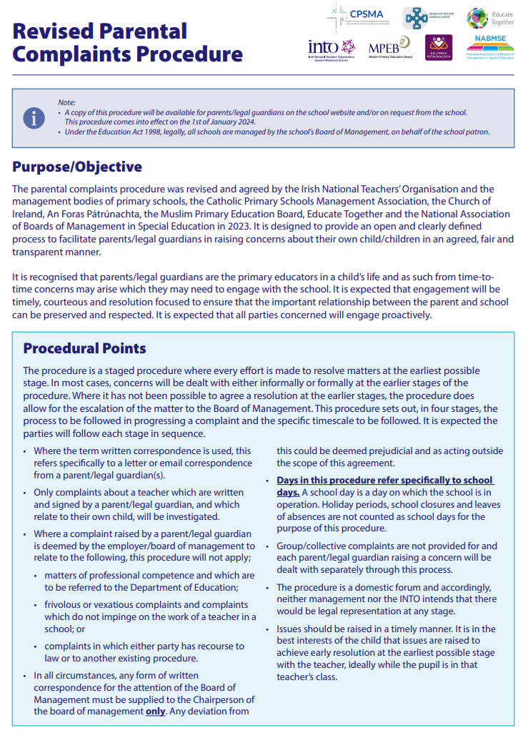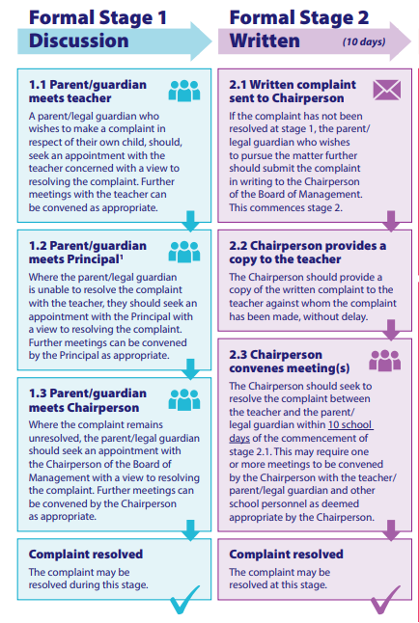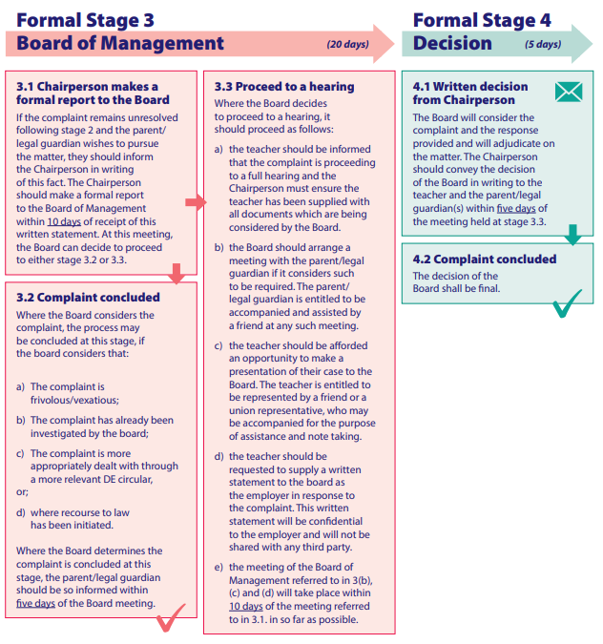

**Appendix 2**

**Grievance Procedure**

The following procedure for handling grievances in schools has been agreed between the INTO and the principal management bodies.

The purpose of this procedure is to provide a mechanism for the resolution of a grievance which a teacher in a national school, including a principal teacher, has against:

* The board of management in respect of the exercise of any of its responsibilities for the governance of the school; or
* The chairperson of the board in an individual capacity; or
* The principal teacher in respect of his/her duties and responsibilities for the organisation, conduct and day to day activities of the school.

The grievance procedure shall generally relate to breaches of school rules, policies, procedures or practices. The grievance procedure shall not deal with curricular matters. If a grievance, which concerns a matter covered by the Employment Equality Act (1998) or other relevant legislation, is referred to the Director of Equality Investigations or the Labour Court, this procedure shall not be used. Such a referral would serve to terminate the grievance procedure.

**Stage 1: The Principal**

1. The aggrieved teacher shall give notice in writing to the principal that the grievance procedure is being invoked.
2. The teacher shall discuss the grievance with the principal teacher with a view to resolving it.
3. If the grievance is not resolved within ten school days, the teacher shall be entitled to invoke Stage 2, within a further ten school days.

**Stage 2: The Chairperson**

1. The aggrieved teacher shall give notice in writing to the principal and chairperson of the board of management that Stage 2 of the grievance procedure is being invoked.
2. The teacher shall discuss the grievance with the chairperson of the board with a view to resolving it.
3. The chairperson shall immediately take such steps as she/he considers appropriate to have the grievance resolved informally.
4. If the grievance is not resolved within ten school days the teacher shall be entitled to invoke stage 3, within a further ten school days.

**Stage 3: The Board of Management**

1. The aggrieved teacher shall give notice in writing to the chairperson of the board of management that stage 3 of the grievance procedure is being invoked.
2. The teacher shall make a written submission which shall include the details of the grievance(s) and the redress being sought. The submission shall be presented to the chairperson for consideration by the board of management.
3. The normal rules of due process shall apply to the exchange of documentationand accordingly, the chairperson shall copy the submission to the person against whom the grievance is being taken.
4. Where the grievance involves the principal teacher, she/he shall be requested by the chairperson to prepare a written response to the submission. The written response shall address all of the points made in the aggrieved teachers’ submission and shall be furnished to the aggrieved teacher(s) within 10 school days of the date of the written submission. Similarly, where the grievance is against the chairperson of the board of management or the board itself, the aggrieved teacher shall be entitled to a written response from the chairperson or the board, as the case may be. Such response shall also be furnished within 10 school days.
5. The chairperson shall invite the aggrieved teacher to be in attendance at a hearing of the board, which shall be held within ten school days of the date of the written response. The hearing shall afford each party to the grievance an opportunity to hear at first hand, what the other party has to say and also to question and/or respond to the other party.
6. In circumstances, where the grievance is against the principal teacher, he/she shall attend at the board hearing in an individual capacity and not as a member of the board of management. Similarly, where the grievance is against the chairperson of the board of management (in an individual capacity) he/she shall also attend at the board hearing in an individual capacity and an acting chairperson shall be appointed. Further, the principal teacher or the chairperson, as the case may be, shall withdraw from the board’s deliberations and decision making on the matter. Where appropriate, the parties shall be entitled to bring witnesses. The same principles of due process apply to hearing witnesses.
7. The board shall try to resolve the grievance by conciliation and if the grievance is resolved the matter is concluded. If the board is unable to resolve the grievance by conciliation it shall make a decision on the matter, except as provided under the point below.
8. In cases where the grievance is against the board itself, the board shall hear the grievance as outlined above, shall try to resolve the matter by conciliation, but failing resolution, the matter may proceed to stage 4 in accordance with the provisions of two points below .
9. The chairperson shall convey the outcome in writing to the parties within 5 school days of the hearing specified at Stage 3
10. The teacher shall have the right to invoke stage 4 of the procedure:
    * *If the board fails to give a hearing to the aggrieved teacher;*
    * *If the chairperson fails to convey the outcome of the hearing within the specified period; or*
    * *If the teacher is unwilling to accept the outcome of stage 3.*

**Stage 4: An Independent Tribunal**

1. The teacher who wishes to proceed with an appeal to Stage 4 shall give notice of same, by letter, to the chairperson of the board of management, within ten school days of receiving the written outcome of Stage 3 (or at the end of the period specified in Stage 3 / no. 5, if the board fails to arrange a hearing). The date of that letter shall be referred to as the “date of appeal” and the teacher may include, in the letter, any additional arguments he/she wishes to put forward.
2. On receipt of the letter of appeal, the chairperson of the board of management shall notify the patron (or a designated representative of the patron) and the General Secretary of the INTO (or a designated representative of the INTO) and invite these parties:

*• To select an agreed independent person to act as chairperson of a tribunal;*

*• Each to appoint a person who is not associated with the school to serve*

*• On the tribunal;*

*• To arrange a meeting of the tribunal within 15 school days of the date of appeal.*

1. The chairperson of the board of management shall also furnish each member of the tribunal, prior to its first meeting:

*• With a report on the proceedings at each of the previous stages;*

*• And with a copy of the aggrieved teacher’s letter of appeal; a copy of the aggrieved teacher’s submission; a copy of any written response; any other relevant documentation.*

1. The tribunal shall arrange a hearing(s) for the parties and shall ensure that the normal rules of due process and fair procedures apply (c/f section b, pgs 12 - 13), which include: *• That the parties shall be given reasonable notice of the hearing by the tribunal. When notifying parties of the date of the hearing(s), the tribunal should indicate to the parties concerned that in the event of failure to appear, without reasonable cause, the tribunal may proceed to decide the case if considered appropriate;*

*• That each party shall be afforded an opportunity to access and respond to relevant documentation, including the letter of appeal;*

*• That the parties shall have an opportunity to hear at first hand, what each has to say and also to question or respond to the other party through the chairperson of the tribunal;*

*• That witnesses may attend as appropriate and that the tribunal itself, shall be entitled to question each party or seek further information;*

*• That where appropriate, the tribunal shall afford each party an opportunity to provide further information, on the clear understanding, that the other party shall have an opportunity to access and respond to same; and • that if necessary, the tribunal shall agree to adjournments.*

1. The tribunal shall be considered a domestic forum and accordingly, neither management nor the INTO intends that there would be legal representation at any hearings.
2. The tribunal shall be empowered to conciliate with a view to reaching a friendly settlement.
3. Failing such a settlement the tribunal shall determine the issue by unanimous or majority vote.
4. The tribunal’s decision shall be conveyed in writing by the chairperson of the tribunal to all the parties and shall be final and binding. Please note that any expenses involved in Stage 4 will be shared by the parties who nominate the tribunal provided that prior sanction for same has been obtained from INTO and the relevant management body.

**Notes**

1. Until such time as the dispute is resolved or determined the aggrieved teacher shall continue to carry out the legitimate instructions of the principal teacher or the board of management as the case may be.
2. The grievance procedure shall also apply where two or more teachers share a grievance.
3. Where a principal teacher, or a principal teacher and one or more other teachers, share a grievance, Stages 2, 3 and 4 of the procedure shall apply.
4. Where the grievance is against an individual chairperson or the board of management itself, Stages 2, 3 and 4 of the procedure shall apply.
5. Where there is a single manager as opposed to a board of management, Stages 1, 2 and 4 only shall apply. In these circumstances the aggrieved teacher shall supply a written submission at Stage 4, and the normal procedures of due process will apply to the exchange of documentation and the right of response.
6. An aggrieved teacher(s) may be represented at Stages 3 and 4 by the INTO staff representative or by a branch or district committee member or by a teacher colleague.
7. Attention is also drawn to paragraph 15 of the Constitution of Boards and Rules of Procedure, particularly with regard to disclosure of interest.
8. Where the aggrieved teacher is a member of a religious order, the INTO will consult her/his representative association before nominating a member of the independent tribunal envisaged in Stage 4.
9. A school day is a day on which the school is in operation.
10. Any difficulty arising out of the implementation of this procedure shall be referred for resolution to the parties to this agreement.