St Oliver Plunkett Primary School
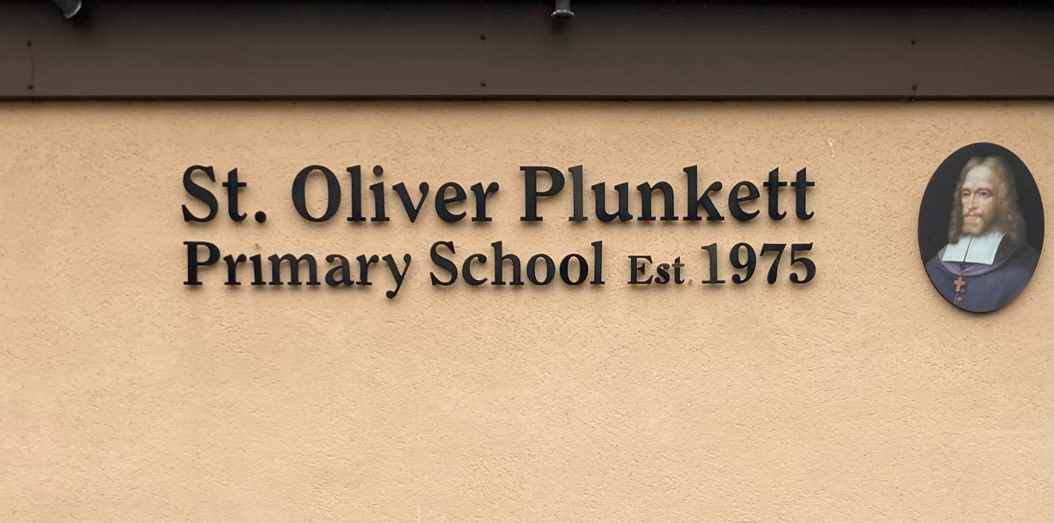
Blackcastle, Navan, Co Meath
Roll number: 19476h
www.stoliverplunkettsnavan.ie
Twitter: @st_navan
Email: stoliverns2@gmail.com
School Patron/s: Bishop of Meath

Protected Disclosures Policy

Contents
1. About this policy 1
2. Personnel responsible for the policy 1
3. What is a protected disclosure? 2
4. Raising a concern 3
5. Confidentiality and anonymity 3
6. Investigation and outcome 4
7. If you are not satisfied 5
8. External disclosures 5
9. Feedback and Corrective Action 6
10. Protection and support for Staff making disclosures 6
11. Contacts 8

About this policy

The Board of Management of St Oliver Plunkett Primary School is committed to operating the School with honesty and integrity and to encouraging openness and accountability in the workplace.

The aims of this policy are to:

Encourage you and the entire staff body to report relevant wrongdoing as soon as possible, in the knowledge that your concerns will be taken seriously and investigated as appropriate;

Provide you with guidance as to how to raise those concerns; and

Reassure you that you should be able to raise genuine concerns without fear of reprisal.

This policy applies to you if you fall within the definition of ‘Staff’ which includes all current and former employees of the Board, officers, consultants, contractors, interns, individuals on training placement, casual workers, agency workers, members of the Board, job applicants and volunteers. For the purposes of this policy, this list of individuals shall be referred to collectively as “Staff”.

This policy does not form part of any Staff member’s contract of employment and the Board may amend it at any time.

In this Policy, the Principal and the Chairperson are responsible for dealing with protected disclosures, except where the Principal is implicated in the protected disclosure (in which case the Chairperson of the Board or the Board if appropriate) will deal with it.

Personnel responsible for the policy

The Board of Management has overall responsibility for this policy, and for reviewing the effectiveness of actions taken in response to concerns raised under this policy.

The Principal and/or the Chairperson will discharge the functions of the Protected Disclosures Officer with operational responsibility for this Policy and must ensure that all Staff who may deal with concerns or investigations under this Policy receive regular and appropriate training.

The Principal and the Chairperson are the “designated person” under this policy for the Purposes of the Protected Disclosures (Amendment) Act 2022.

All Staff are responsible for the success of this policy and should ensure that they use it to disclose any suspected danger or wrongdoing.

What is a protected disclosure?

This Policy aims to protect you from penalisation and/or detriment where you make a disclosure of information that comes to your attention in connection with your work at the school. A protected disclosure under this Policy (which is at times referred to as a disclosure) involves the disclosure of information which you reasonably believe or suspect, demonstrates a relevant wrongdoing or danger at the School.

Disclosures which are protected may include information about:

the committing of an offence;

failure to comply with a legal obligation; (other than one arising under the Staff’s member’s contract of employment or engagement

miscarriages of justice;

danger to health and safety of an individual;

damage to the environment;

unlawful or improper use of funds and/or resources of a public body, or of other public money;

an act or omission of a public body is oppressive, discriminatory, grossly negligent or constitutes gross mismanagement;

a breach of any area of EU law provided for under the Protected Disclosures (Amendment) Act 2022, available at https://www.irishstatutebook.ie/eli/2022/act/27/section/4/enacted/en/html#sec4;and
    - the deliberate concealment of any of the above matters.

If you have any genuine concerns related to suspected wrongdoing or danger affecting any of the School’s activities you should report it under this Policy.

This Policy should not be used for complaints relating to your own personal circumstances, or arising out of your contract with the Board, such as the way you have been treated at work. In such cases you should use the Grievance Procedure or other appropriate policy.

If you are uncertain whether something is within the scope of this Policy you should seek advice from the Principal or Chairperson whose contact details are at the end of this Policy.

Raising a concern

The Board hopes that in most cases you will be able to raise any concerns identified in section 3 above with your Principal or Chairperson , either in person or by putting the matter in writing if you prefer. The Principal or Chairperson may be able to agree a way of resolving your concern quickly and effectively. Where you feel that the Principal has not addressed your concern, or you prefer not to raise it with them for any reason, you should contact the Chairperson of the Board.

The Principal or the Chairperson shall issue an acknowledgement to you in writing of receipt of the report not later than 7 days after receipt of it.

A report may also be made orally by telephone or through another voice messaging system.

A meeting will be arranged with you as soon as possible to discuss your concern. You may be accompanied by a consenting colleague or trade union representative at any meeting under this Policy. The representative must respect the confidentiality of your disclosure and any subsequent investigation.

A written summary will be taken down of your concern and you will be provided with a copy after the meeting. You will also be given an indication of how it is proposed to deal with the matter.

Confidentiality and anonymity

The Board hopes that you will feel able to raise concerns openly under this policy. However, if you want to raise your concern confidentially, all reasonable steps will be taken to avoid disclosing your identity or the identity of any persons named in the report who are alleged to have committed or are associated with the relevant wrongdoing.

The Board does not encourage you to make disclosures anonymously. The Principal or Chairperson may exercise their discretion, not to accept and/or follow-up on an anonymous report, unless it is appropriate to do so in the circumstances. Proper investigation may be more difficult or impossible if the Principal or Chairperson cannot obtain information from you which is necessary for the purpose of conducting a fair and comprehensive investigation. You should be aware that the Principal or Chairperson and the Board may not be able to take any action in respect of an anonymously made protected disclosure if it needs to rely on your identity and/or co-operation for the purposes of dealing with the protected disclosure.

If you wish to disclose your concerns under this policy but are apprehensive about possible reprisals if your identity is revealed, you should come forward to the Principal or Chairperson and appropriate measures can then be taken to preserve confidentiality if and where possible.

Following your consideration of clauses 5.1 and 5.2, if you remain of the opinion that you wish to make your protected disclosure on an anonymous basis, you can do so.

Investigation and outcome

Once you have raised a concern, an initial assessment will be carried out by the Principal or Chairperson in his/her capacity as the Protected Disclosures Officer (“PDO”) to determine whether there is evidence that a relevant wrongdoing may have occurred. If it is established that there is no evidence that a relevant wrongdoing may have occurred, the PDO may close the investigation. However, if after having carried out an initial assessment, the PDO decides that there is evidence that a relevant wrongdoing may have occurred, the scope and terms of reference of any next steps which may include an investigation which the PDO might decide to carry out shall be determined as appropriate.

You will be informed of the outcome of the assessment. You may be required to attend additional meetings in order to provide further information. For the purpose of this section, it is assumed that the Principal or Chairperson will carry out the investigation. In some cases the Principal or Chairperson may appoint (with the approval of the Board) an investigator or team of investigators including Staff who are unconnected with you and who have relevant experience of investigations or specialist knowledge of the subject matter to report on their investigation. The Principal or Chairperson may also appoint (with the approval of the Board) an external investigator if he/she believes it would be appropriate to do so.

The investigator’s report will be sent to the Principal or Chairperson who will determine what if any action should be taken by the School. Such action could include, by way of example, changes to the way the School conducts its operations, disciplinary action (following the application of the disciplinary procedure) or a referral to an appropriate third party such as An Garda Sίochána or an appropriate person or body.

The investigator may at his/her discretion circulate his/her draft report to all persons who have participated in the investigation in advance of finalising such report.

The Principal or Chairperson will aim to keep you informed of the progress of the investigation and its likely timescale. However, sometimes the need for confidentiality or to facilitate a fair and comprehensive investigation may prevent the Principal or Chairperson giving you specific details of the investigation. You should treat any information about the investigation as confidential.

If the investigation concludes that you made false allegations deliberately, maliciously or with a view to personal gain, you may be subject to disciplinary action in accordance with the disciplinary policy and procedure. Alternatively, if you are not an employee of the School, your contract may be terminated in accordance with the terms of the contract.

IF YOU ARE NOT SATISFIED

While the School cannot always guarantee the outcome you are seeking, it will try to deal with your concern fairly and in an appropriate way. By using this policy you can help us to achieve this.

If you are not happy with the way in which your concern has been handled, you may contact the Board of Management. Contact details are set out at the end of this policy. The Board may request written submissions in advance of making a decision as to the subject matter of the appeal.

External disclosures

The aim of this policy is to provide an internal mechanism for reporting, investigating and remedying any wrongdoing in the workplace. In most cases you should not find it necessary to alert anyone externally.

The law recognises that in some circumstances it may be appropriate for you to report your concerns to an external body such as a prescribed person (such as a regulator), the Minister for Education or the Protected Disclosures Commissioner (within the Office of the Ombudsman). It will very rarely - if ever - be appropriate to alert the media and in general you should only do so as a last resort. As there are specific provisions applicable to external disclosures, the Board strongly encourages you to seek advice before reporting a concern externally. A list of prescribed persons and or bodies for reporting certain types of concern is available from the Principal or Chairperson.

Although Whistleblowing concerns usually relate to the conduct of persons who are Staff members or members of the Board, they may sometimes relate to the actions of a third party, such as a supplier or service provider. In some circumstances the law may protect you if you raise the matter with the third party directly. However, the Board encourages you to report such concerns internally first under this policy. You should contact your Principal or Chairperson for guidance.

Feedback and Corrective Action

The Principal or Chairperson will provide feedback to you no later than three (3) months after issuing the initial acknowledgement in accordance with clause 4.2 above. In circumstances where it is likely that the Principal or Chairperson will not be in a position to provide feedback within three (3) months, they should notify you, in writing, as soon as practicable. Similarly, where the investigation does not conclude within three (3) months, feedback will be provided to you at intervals of three (3) months until the investigation is concluded. While the School will use its best endeavours to comply with these timeframes, if it cannot reasonably do so, it will notify you of any revision to them.

The feedback should include the outcome of any enquiry carried out and/or any planned remedial action such as changes to policies and procedures. Disclosures may, in light of the seriousness of the matters raised be referred to the appropriate authorities. Likewise, if urgent action is required (for example to remove a health and safety hazard) such action may be taken.

Protection and support for Staff making disclosures

It is understandable that Staff members who make protected disclosures are sometimes worried about possible repercussions. The Board aims to encourage openness and will support you if you raise genuinely held concerns under this policy, even if those concerns turn out not to be well founded.

Staff members who make protected disclosures under this policy will not suffer any penalisation or detrimental treatment as a result of raising a concern. Penalisation refers to any direct or indirect act or omission which occurs in a work-related context, is prompted by the making of a report and causes or may cause unjustified detriment to a Staff member, and, in particular, includes;

suspension, lay-off or dismissal,

demotion or loss of opportunity for promotion, or withholding of promotion;

transfer of duties, change of location of place of work,

reduction in wages or change in working hours,

imposition or administering of any discipline, reprimand or other penalty (including a financial penalty);

unfair treatment,

coercion, intimidation or harassment, or ostracism;

discrimination or disadvantage,

injury, damage or loss,

threat of reprisal;

withholding of training;

a negative performance assessment or employment reference

failure to convert a temporary employment contract into a permanent one, where the employee had a legitimate expectation that he or she would be offered permanent employment;

failure to renew or early termination of a temporary employment contract

harm, including to the reporting person’s reputation, particularly in social media, or financial loss, including loss of business and loss of income

blacklisting on the basis of a sector or industry-wide informal or formal agreement, which may entail that the person will not, in the future, find employment in the sector or industry

early termination or cancellation of a contract for goods or services

cancellation of a licence or permit; or

psychiatric or medical referrals.

If you believe that you have suffered any such treatment, you should inform the Principal or Chairperson immediately. If the matter is not remedied you should raise it formally using the Grievance Procedure or other appropriate procedure.

You must not threaten or retaliate against Staff members who make protected disclosures under this policy in any way. If you are involved in such conduct you may be subject to disciplinary action.

While your motivation for making a disclosure under this policy is irrelevant, if you make a disclosure in the absence of reasonable belief, you may lose the protection of the Act and you may be liable to a disciplinary sanction.

In addition, you should be aware that disclosure of a relevant wrongdoing does not confer any protection of immunity on you in relation to any investigation that might take place in relation to such wrongdoing.

Contacts
The Principal name is Padraig Farrell whose contact details are St Oliver Plunkett Primary School, Blackcastle, Navan, Co Meath (C15R642).
The name of the Chairperson of the Board of Management is Helena Gibbons whose contact details are St Oliver Plunkett Primary School, Blackcastle, Navan, Co Meath (C15R642).
The contact details for the Minister for Education are minister@education.gov.ie, Minister's Office, Department of Education, Marlborough Street, Dublin 1.

Ratification and Review

This policy will be reviewed annually and brought to the Board of Management. It was reviewed on November 30th 2023.

Pádraig Farrell Helena Gibbons

(Principal) (Chairperson, BoM)

