St Oliver Plunkett’s Primary School
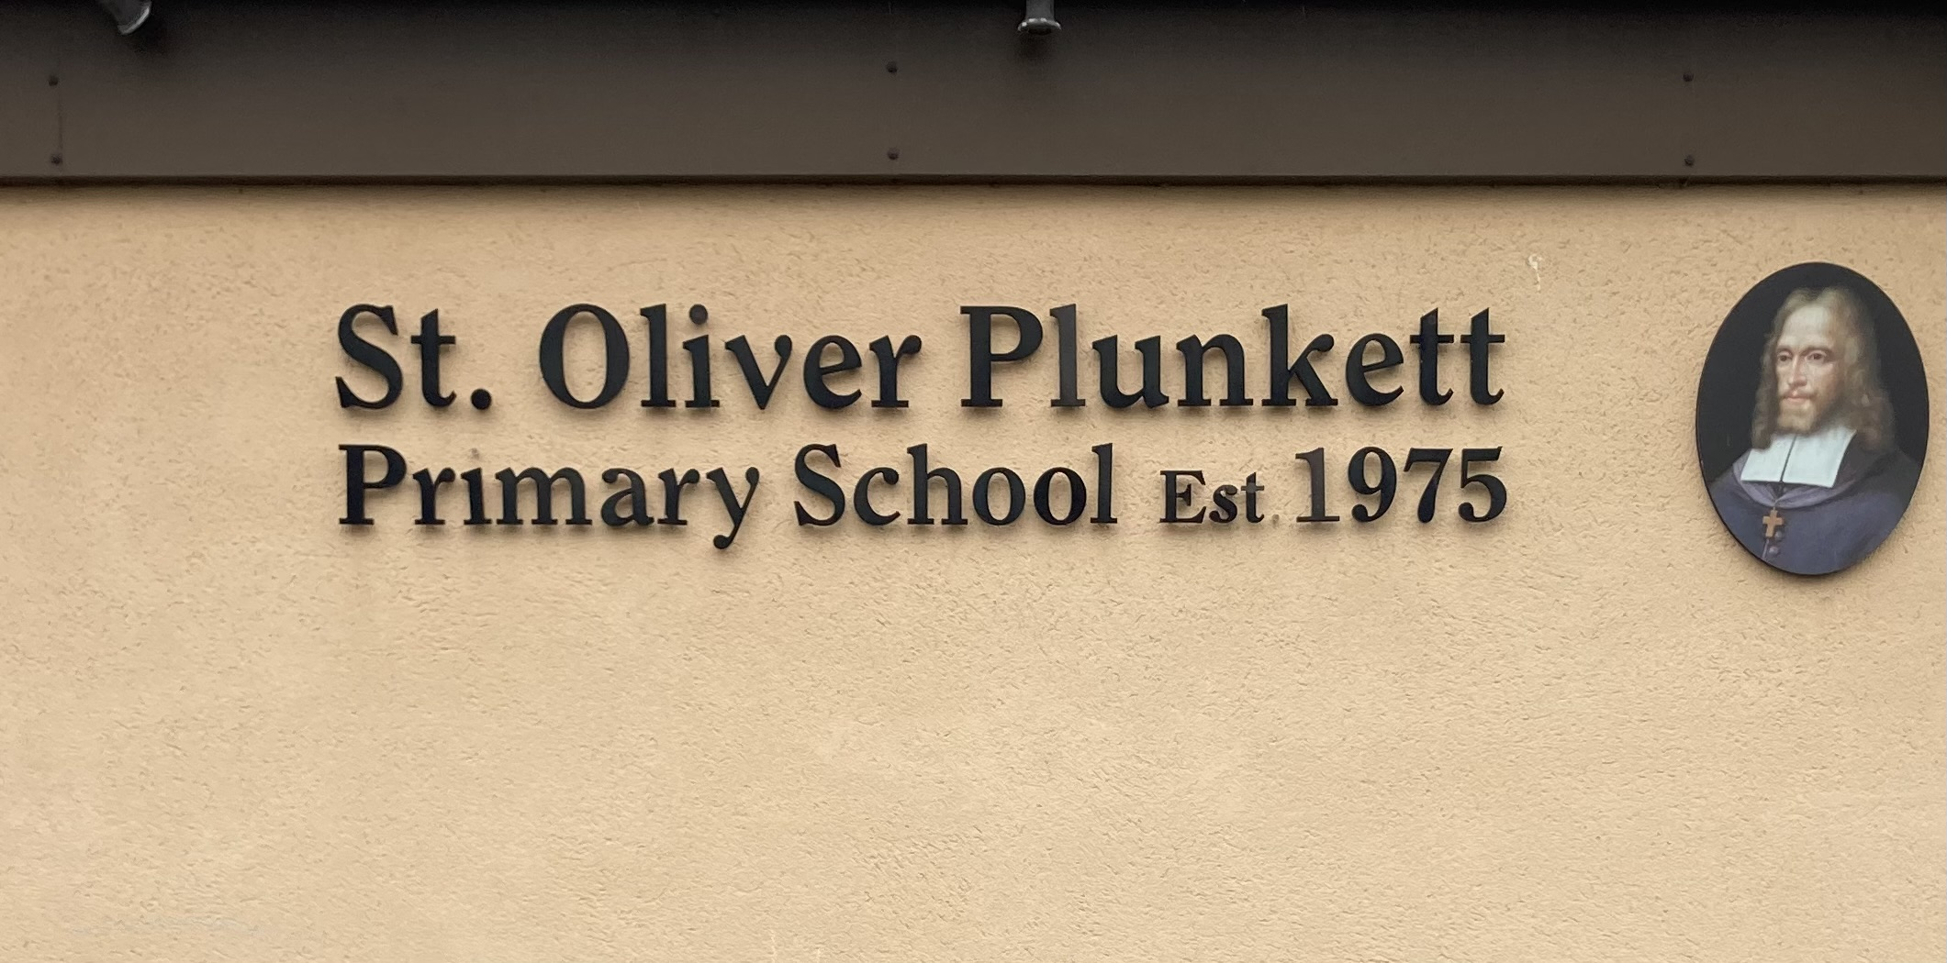
Blackcastle, Navan, Co Meath
Roll number: 19476h
www.stoliverplunkettsnavan.ie
Twitter: @st_navan
Email: stoliverns2@gmail.com
School Patron/s: Bishop of Meath

Policy for Butterfly & Caterpillar
Rooms

1. Introductory Statement
The decision to provide a Special Class for Autism Spectrum Disorder (ASD) in St Oliver Plunkett Primary School was taken by the Board of Management, in conjunction with the principal, staff and school community in the school year 2022/2023. The first class was aken in September 2023 with the second class enrolling for September 2024. The 2 rooms are called the Butterfly and Caterpillar Rooms. The decision was made with a view to providing an appropriate, specialist education within a mainstream setting for children with a diagnosis of ASD and who meet the enrolment criteria.

2. Rationale
This policy was formulated in order to clarify the roles and responsibilities of staff in the provision of this specialised education. In formulating this policy, we consulted the following documents:
- NCSE Guidelines for Setting Up and Organising Special Classes
- NCSE: An Evaluation of Education Provision for Students with Autism Spectrum Disorder in Ireland (2016)
3. Relationship to the Characteristic Spirit of the School
According to the NCSE,
‘Special Classes are part of a continuum of educational provision that enables students with more complex special educational needs to be educated, in smaller class groups, within their local mainstream schools. They offer a supportive learning environment to students who are unable to access the curriculum in a mainstream class, even with support, for most or all of their school day.’
Our decision to open Special Classes for ASD reflects our school charter to “promote the full and harmonious development of all aspects of the person of the pupil: intellectual, physical, cultural, moral and spiritual, including a living relationship with God and with other people. The school models and promotes a philosophy of life inspired by belief in God and in the life, death and resurrection of Jesus Christ.”

4. Aims and Objectives:
- To outline the roles and responsibilities of the principal, ASD class teachers, mainstream class teachers and Special Needs Assistants (SNAs)
- To provide guidelines on the development of a suitable, positive learning environment, including the appropriate use of language
- To outline approaches to integration and inclusion for children in the Special Classes
- To outline approaches to integration of all the school community in the work of the Butterfly & Caterpillar Room
- To outline approaches to teaching and learning
- To outline planning and paperwork requirements
- To outline the schools approach to staffing in relation to the special class
- To encourage participation in ASD-specific Continued Professional Development (CPD) in order to enrich teaching and learning in the Special Classes
- To establish the link between the Code of Behaviour and classes for children with ASD

5. Roles and Responsibilities
Special Class Teacher | Classroom Teacher
- Being the main point of contact for the child’s parents/guardians  - Developing a suitable classroom environment  - Coordinating and implementing education and behaviour plans  - Communicating plans and strategies to SNAs and other relevant staff  - Fulfilling planning and paperwork requirements  - Co-ordinating the supporting work of the SNAs on an ongoing basis  - Working with mainstream teachers to identify opportunities for meaningful integration and necessary accommodations  - Upholding the Code of Behaviour | - Working with the ASD-class teacher to identify regular opportunities for integration or reverse integration, where appropriate  - Working with the ASD-class teacher and SNAs to implement accommodations that the child with ASD may need to be successful in the mainstream classroom, where appropriate  - Being aware of children’s learning targets during integration and using appropriate strategies and methodologies, as guided by the ASD class teacher  - Providing input, where appropriate, during the review stages of the IEPs
SNA | School Management
- Assisting with the care/safety/supervision needs of the children – in the classrooms and around the school, on the playground and on school trips  - Assisting with behavioural management programmes  - Guiding the child through tasks and activities designed by the ASD-class teacher or the mainstream class teacher  - Data collection/reporting on progress as determined by the ASD-class teacher or Principal  - Preparing materials/resources for the children, under the guidance of the ASD class teacher  - Providing input during the review stages of the IEPs and attending IEP review meetings | - Assume overall responsibility for the development and implementation of this policy in co-operation with the BOM, teachers, parents and children  - Staffing arrangements, i.e. SNA supports, teachers, substitutes, bus escorts  - Uphold the Code of Behaviour of the school  - Management of the enrolment process  - Support teachers to increase their knowledge and skills in the area of ASD

6. Support in St Oliver’s for children in the Special Class
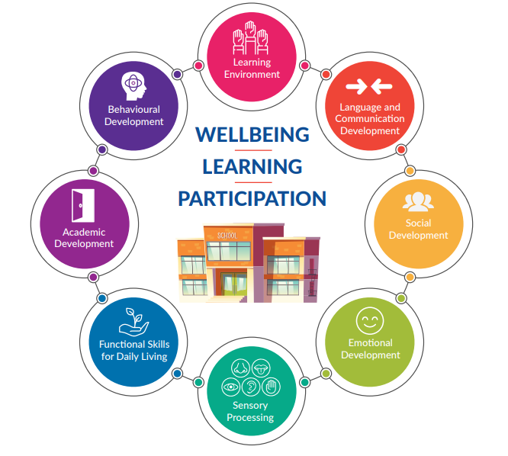
In St Oliver Plunkett Primary School we endeavour to follow the key indicators of Good Practice in relation to autism as outlined by the Department of Education. The following are key indicators of best practice we work towards. At the end of the Academic year the Class teachers will come together with Principal and Deputy Principal to evaluate the success in each area. Appendix A will be the template filled out in this regard.
Classroom Environment
- The classroom is arranged to allow accessibility and easy management of materials (e.g. use of labels, visuals and colour coding)
- Sensory stimuli (e.g. noise and light) are considered when preparing a workspace/ workstation which may be used for short periods, as appropriate
- Adaptions are in place to address sensory needs
- A calming space is available to support emotional and/or sensory regulation as required
- Visual schedules/timetables are used to provide predictability and structure to the school day
- Individualised visual supports are used to support learning and task engagement
- Visual schedules and routines have been established to support transitions between activities/environments
- A consistent and clear timekeeping method is provided for students as required (e.g. sand timers/digital timers)
- Class rules and routines are developed in collaboration with students and regularly reinforced using visual aids
- Behavioural expectations are developmentally appropriate and meaningful for students
- Task expectations are set out clearly and supported by visual aids

Language & Communication
- Students’ motivation to communicate and attend to instruction is promoted (e.g. use of high interest topics and activities)
- Teaching approaches are adapted by reducing and simplifying language, avoiding the use of ambiguities and idioms and providing sufficient time for the student to process and understand verbal instruction
- Students have access to alternative or augmentative communication systems where necessary
- Language and communication skills are explicitly taught and opportunities to practice in different situations and contexts to promote generalisation
- Students’ language and communication skills have been reviewed in collaboration with school staff, parents and SLT as appropriate.
- Students’ views are considered as part of this process
Social Development
- A variety of evidence-informed approaches, (e.g. scripting, modelling, prompting and reinforcement strategies) are used to teach social skills and to promote social interaction
- Opportunities are provided to practice social skills across home and school to increase the generalisation of skills Incidental teaching, planned learning opportunities and peer support programmes are used to promote skills development
- The school community supports students with autism to use social skills in daily school activities through scaffolding and structured opportunities
- Support plans include strategies to develop participation in leisure and recreational activities
- The school’s anti-bullying policy is reviewed to ensure a safe environment

Emotional Development
- Collaborative home/school links are developed which focus on building positive relationships and on fostering the mediating role supporting adults play in promoting emotional development
- The school has accessed external professional advice as necessary, to meet students’ emotional wellbeing needs
- Opportunities for the teaching of emotional awareness are incorporated into interventions across the Continuum of Support Interventions for supporting emotional development are based on an understanding of the Emotional Arousal Cycle
- Students are supported in identifying causes of emotional dysregulation in themselves and others
- Students are provided with opportunities to practice and generalise a range of emotional coping strategies and problem-solving skills

Sensory Processing
- Classrooms and school spaces are organised to minimise sensory experiences that may be distracting/ uncomfortable for students
- Students have access to sensory experiences required for self-regulation as indicated in their sensory diet or profile (e.g. a quiet area, movement breaks)
- Students are facilitated in indicating their need for a movement/sensory/calming break as necessary
- Student responses are monitored and recorded when introducing new sensory strategies/activities and modifications made as required
- Students are prepared in advance, for sensory stimuli which may be present in new activities or environments
- Sensory based recommendations are consistently implemented by all staff, across all school settings
Functional Skills for Daily Living
- In collaboration with parents and students, information is gathered on students’ functional skills across school and home settings
- Students’ demonstration of functional skills has been observed and assessed, as either emerging/completed with assistance/prompting, completed independently, or demonstrated across settings
- Priority targets have been identified to promote students’ problem-solving skills and level of independence Intervention
- Structured teaching and learning activities and modifications to the school environment are used to promote students’ engagement and independence
- Functional skills are divided into incremental steps that are taught and reinforced using visual approaches
- Functional skills are promoted through the curriculum and through targeted interventions at group and/or individual level
- Students are provided with opportunities to practice skills across home and school settings
Academic Development
- Information is gathered on how well the environment is structured to meet the needs of autistic students, in addition to data on their strengths, abilities, areas of interest and motivators for learning
- Assessment methods are adapted to meet the needs of students with autism, and information is gathered on their learning profile and progress across the curriculum
- Intervention Students have access to a broad, adapted curriculum and to certified learning options as appropriate
- Differentiation of teaching approaches, materials, content and pace, match lessons to students’ needs
- Language differences are considered when planning academic tasks and appropriate modifications and supports provided
- In partnership with parents, students’ strengths and interests are incorporated into academic tasks, and students are supported to participate in setting learning goals.
- Academic instruction is informed by a variety of evidence-informed teaching approaches including: Visual structured teaching approaches; Behavioural teaching approaches; Communication based programmes
- Strategies are in place to support organisational skills and to foster independence around study skills and examination preparation
- Digital learning and assistive technology approaches are used to support students’ communication and learning
Behavioural Development
- A student’s behaviour has been observed and consideration given to basic needs, environmental and interpersonal supports, skill development needs, and an understanding of the possible function of the behaviour
- A person-centred approach is used to enable students to communicate their views, experiences and what might help meet their needs Information has been gathered from a range of sources, as part of a comprehensive, holistic approach to understanding the student’s behaviour across contexts
- Intervention Students, parents and school staff have been consulted on strategies to improve the student’s quality of life by reflecting on their strengths, needs, skills and experiences
- Planned proactive approaches using positive behaviour supports, are in place at whole-school, class, and individual levels, to address behaviours of concern
- Proactive strategies, informed by an understanding of the possible reasons why the behaviour is occurring, are included in the student support plan to: Address any unmet basic needs; Respond to strengths and needs across domains; Create supportive environments; Strengthen interpersonal supports; Teach and reinforce targeted skills
- Reactive strategies are in place if required, including low arousal approaches and ensuring the safety of the student and others

7. Approaches to Teaching & Learning

Pupils in the autism class will access an education based on the Primary School Curriculum, which will be adapted according to their individual needs and capabilities through carefully planned differentiation and appropriate teaching methodologies. The NCSE Guidelines for Teachers of Students with General Learning Disabilities may be used to augment the implementation of the curriculum.

Children who have a recommendation for a place in a Special Class for ASD do not necessarily qualify for an exemption from Gaeilge. An exemption must be recommended by a psychologist or a speech and language therapist. This exemption must be applied for through the principal of the school. It is the responsibility of the parents to ensure their child has the appropriate exemption, if necessary. If an Irish exemption is granted, our pupils will be provided with opportunities to participate in Irish language and cultural activities that are appropriate to their learning needs.

The Stay Safe and RSE programmes are compulsory and must be delivered at an appropriately differentiated level as part of the whole school SPHE plan.

Teaching methodologies will include, but are not limited to:
- Aistear/Play based learning
- Treatment & Education of Autistic and related Community Handicapped Children (TEACCH)
- Picture Exchange Communication System (PECS)
- Social stories
- Floortime
- Lámh

8. Integration

Pupils in the autism class will have opportunities to play, socialise and learn alongside their peers in the mainstream class. All integration will be coordinated by those working with the child after meeting the child’s parents to discuss same.
- Clear goals will be agreed and set by all those involved
- The autism class teacher and the mainstream class teacher will agree a time when integration can take place, which will be of greatest benefit to the pupil and the mainstream class
- Initially the period of integration will be kept short to allow the child to become accustomed to a different environment. This time period will gradually be increased whilst always being cognisant of the child’s needs
- The autism class teacher will keep parents informed of progress made during integration periods
- The pupil from the autism class will be supported prior to and during integration through the use of visuals, simple and clear explanations, going on short visits/messages to the mainstream teacher, adaptations in the classroom etc.
- Reverse integration will be organised for any child who is unable to tolerate integration into a different classroom setting
- Small groups of children (2 or 3) of a similar age from other classes will be invited to visit the autism classroom for play and social interaction on a rotational basis
- Small groups from 6th Class will work on a rota at break times to interact with the children
- On Fridays the children on the yard rota will come to the Caterpillar and Butterfly Rooms for tea and toast
- Pupils from the autism class will participate as much as possible in whole school events such as assemblies, sports days, Active Schools Week, X-Factor, Olivers Can Dance, Musicals, School plays School tours and other gatherings. Adaptations will be put in place where possible to allow for greatest possible participation.

9. Assessment

The class teachers in the Butterfly Room and Caterpillar Room are required to keep an assessment folder with information relating to the learning progress of the pupils. Assessment methods will be similar to those that are employed in mainstream classes:
● Checklists
● Observation profiles
● Teacher designed tasks and tests
● Portfolio of work (work samples)

Autism-specific assessment and profiling tools will be used to get a baseline of the child’s abilities and identify areas for development/targets and also monitor progress. These assessments will be used to set specific individualised targets for pupils’ School Support Plans. Autism-specific tools may include:
● Psychoeducational Profile - Third Edition (PEP-3)
● Quest diagnostic test

Note: Children in 2nd, 4th and 6th class are not exempt from Standardised Testing without
prior approval from the principal.

10. Transition

Transitions within the school day

Daily transitions within the school day should be planned, predictable and calm, as much as possible. Unplanned changes to routines should be communicated calmly using visuals. The following strategies should be used to support transitions:

- Routine regarding pick up from the bus and departure to the bus
- Visual schedules or First/Then charts
- Social stories (for introducing new routines, e.g. integration sessions)
- Visual timers or countdown to signal the change
- Clear, unambiguous use of language

Transitions into the Butterfly & Caterpillar Rooms

The following guidelines should be followed to help to prepare a child before transitioning to our Specific Classes for ASD:

- Principal and/or ASD-class teacher to meet with the child’s parents to discuss strengths, interests, sensory preferences, motivators as part of Induction day for new children in the June before they start.
- ASD-class teacher to contact the child’s previous setting (e.g. pre-school, crèche, home) to liaise with staff in this setting.
- ASD-class teacher to access child’s professional reports and previous IEPs where possible.
- Provide the child’s parents with a social story to include pictures of the school, the classroom and, where possible, the staff working in the class, the bus and the bus escort
- Invite the child and his/her parents for a visit to the class when other children are not there to allow him/her to explore the environment and meet the teacher and SNAs
- The above information should be recorded, stored in the child’s Support file and used to begin the child’s individualised planning process
- Provide the parents with a transition schedule to outline the dates and times for which the child will attend for the first 3 weeks of school. Generally this will involve a 12.00 finish for the 1st 2 weeks. The child should be on a full day within one month where possible. This transition schedule should be approved by the principal or the ASD-coordinator before being shared with parents.

11. Planning

The ASD-class teacher is responsible for meeting the following planning requirements

1. Individual Support Plan
The pupil’s profile documents his or her current level of performance across learning areas, e.g. literacy, numeracy, language and communication, behaviour, emotional development, leisure skills, social interaction, play and independence skills. Information on effective teaching methodologies or learning style should also be included. A formal review of this profile should be coordinated by the class teacher for each child in collaboration with his/her parents each October & January.

2. Individual Education Plan (IEP)

Short-term SMART targets are reviewed and updated monthly, and shared with parents. Targets should be realistic so that progress can be observed from month to month. Targets should be included across different learning areas to promote social and emotional well-being, as well as academic learning.

3. Monthly group plan

Short-term plan for thematic group activities, e.g. Story time, Maths Topic, SESE, SPHE, Social skills, PE, Arts, etc.

4. Cuntas Míosúil

- Progress review and evaluation of IEP targets, noting targets achieved
- Progress review and reflection on monthly group plan

5. Monthly Health and Safety Audit

This should focus on behaviour concerns or medical conditions to ensure school management are informed. See Appendix B.

Depending on the needs of the children in the class, the class teacher may also be required to develop the following additional documents:

6. Behaviour Plan

This may be required if specific behaviour management strategies and approaches need to be implemented with a child. The plan should be based on behaviour data collected regarding functions of behaviours and potential triggers. Strategies should be shared with all staff who work with a child so that they can be implemented consistently. See template in Appendix C.

7. Intense Behaviour Management Plan

If /when a child’s behaviour is a consistent risk to the teaching and learning of others and/or risk to the health and safety of other pupils/staff, child may be placed on a Safety Specific Behaviour Plan. This plan is drafted in conjunction with NEPS, staff, parents and BoM and is adapted to individual needs. It contains an emergency plan if/when an incident occurs. See Google Drive / school intranet for template and in Appendix
D.
8. Intimate Care Needs Plan

This may be required if a child needs specific regular support or assistance with intimate care needs such as toileting. Staff may seek advice or support from external professionals as required. Please refer to the Intimate Care Needs Policy. Template in Appendix E

9. Substitute file Class

Teachers should develop a folder of work for substitute teachers to include the following:
- Pupil passport page or one-page summary of pupil needs
- Timetables
- One-page summary of strategies and approaches used in the class. This be laminated and put on display for visitors to the class.
- Suitable work or work plans in the event of teacher’s absence.

10. Code of Behaviour

The school Code of Behaviour applies to all children in the school, including the children in the special class for autism. It is accepted that children with autism may display challenging, defiant or oppositional behaviour. All efforts will be made by the school to manage such behaviours according to specific strategies outlined in a child’s behaviour plan. Differentiation is an important aspect of the child’s Behavioural Plan taking into account their own unique circumstances.

11. Confidentiality

Pupils and staff will be treated with dignity and respect at all times. Issues relating to the behaviours or care needs of the children should not be discussed with staff (teachers, SNAs, bus escorts etc) outside of the classroom or principal’s office.

12. Staffing

Staffing in the Butterfly Room and Caterpillar Room is treated the same as staffing in any class in St Oliver Plunkett Primary School. It will be the responsibility of the Principal to decide class allocation. It will always be the aim that teachers are allocated a class that suits their particular skill set but likewise it is healthy for all teachers to have a variety of different classes. It will at all times be the aim of the school that teachers will receive specific training in light of the different challenges that teaching a class with ASD diagnoses can bring. These training opportunities are further elaborated on in Section 14. In saying that it is our goal as a school to ensure inclusion and equality of education for all our students regardless of their educational needs. As such it would be expected that all teachers in the school are available to teach in a special class.

- The teaching term in the special class in St Oliver’s will be preferably 2 years. In a situation where a teacher wishes to leave after 1 year this will be facilitated.
- A teacher will be allocated the special class in early June and thus will have an opportunity to shadow the existing teacher in the special class for 3 days in the final month.
- If a teacher wishes to extend their teaching term the Principal will consider such a request but also keeping in mind other teachers who also have the special class down as a first preference.
- Once a teacher has served 2 years in the Special Class they will not be given this choice again until every teacher has completed a similar teaching term or until they themselves request the position.
- A rota will be drawn up between all teachers to cover teacher absence in the special class. Once a teacher has subbed for a special class teacher their turn will not come around again until all other staff members have subbed. If a mainstream class teacher is next on the list, their class will be catered for on that day. This ensures all teachers get an opportunity to experience working in a special class.
- Special Class teachers will take part once a fortnight in different SET initiatives such as reading groups, Literacy Hour, SRA or Ready Set Go Maths. They will swap with a SET teacher for that hour. This also will be done through a SET Rota.
- Board of Management to facilitate further staff development in the area.

13. Communication with Parents

The staff of St Oliver Plunkett Primary School recognise that the child’s parents are the primary educators of the child. In order to promote a successful and positive school experience for the child, it is important that parents are actively involved in the child’s education and are regularly informed on what is happening in class.
We support communication with parents in the following ways:

- Communication journal: Used by parents and teachers to inform one another of the child’s mood before school and throughout the day, toileting, eating, independence and a short comment when relevant relating to other significant events.
- Phone calls: Parents should be phoned in the incidence of more serious behaviours
- Meetings: IEPS meetings are scheduled twice per year; parent-teacher meetings are scheduled twice per year; further meetings are scheduled as required
- Sharing documents: Class teachers will print and share copies of monthly targets with parents. Parents will be provided with copies of Pupil Profiles and other relevant documents at IEP meetings.
- Email: Parents can contact class teachers by email as required. Class teachers will respond to emails during his or her working hours.
- Class blogs: Teachers share pictures and details of class activities and events on school newsletter and X accounts

14. Role of Special Class Co-ordinator

The Special Class Co-ordinator will work alongside the Principal in organising the Special Classes responding to different needs that might arise. This role will be filled by the Deputy Principal. The role will include

- Liaising with Special Class teachers on a weekly basis in relation to different issues that may arise
- Meeting with the SNA team to discuss their role
- Overseeing the collection of documentation in relation to Behavioural Plans, IEP’s and Intimate Care Plans
- Developing opportunities for integration in the school community
- Identifying opportunities for training for all teachers in the area of autism
- Collaborating with the Principal & SENCO in relation to integration and SET Rotas
- Responsibility for Staff Rotas in relation to subbing in Special Class
- Responsibility for yard duty and lunch breaks in relation to Special Class teachers and SNAs
- Identifying areas of need in relation to resources
- Liaising with parents along with the Principal

14. Well Being

The wellbeing of all our pupils is of utmost importance in St Oliver Plunkett Primary School. It is acknowledged that the children attending the special class may need extra support to help safeguard and foster their wellbeing. The following supports are in place:

- Total communication approach: All types of positive communication will be fostered and encouraged, including but not limited to; visual prompts and schedules, use of gestures and
- Lámh signs, PECS, oral language, drawings, written messages, use of technology etc.
- Calm environment: the children will be provided with a calm and safe classroom. Their sensory needs will be catered for by providing a quiet, dark calm down area within the classroom and a multi-sensory area.
- Positive relationships: a key cohort of staff will consistently work within the special class and all efforts will be made to foster caring and positive relationships with the children.
- SPHE curriculum: emotional awareness, relaxation, friendship and resilience skills will be taught through the SPHE curriculum.
- Communication with parents: a two way open communication approach is strongly encouraged, with the child’s wellbeing central to all interactions.

In relation to staff, it is acknowledged that the autism class can be a high-energy, busy environment to work in. The following supports are in place to safeguard and foster staff wellbeing:
- Team meetings: staff are encouraged to check in with one another informally at the end of each day to discuss the day, complete observational notes and to plan for the following day. More formal planning meetings will take place as part of Croke Park hours.
- Meetings with the principal & Special Class Co-ordinator when required, can take place to discuss any issues that arise. The class teachers meet separately with the Principal on Friday afternoons.
- Break times: Staff working in the autism class should decide together when is best for the various staff breaks to take place. This should be done with a children-first mindset, whilst also ensuring staff have breaks with colleagues as much as possible, to avoid isolation. It is acknowledged that due to unforeseen circumstances, it is not always possible to take breaks at the designated times. It is advised that staff make every effort to take their breaks at the designated times or as soon as possible afterwards.
- Class teachers in the Butterfly Room and Caterpillar Room are not requested to be a part of the yard-duty rota in the month of September.
- Every second Friday the teacher in the special class will swap with a different class/SET teacher in order to ensure they keep informed on changes in classroom teaching.
- Spectrum Life on behalf of the DE, offers a 24 hour employee assistance service, which includes counselling. They can be contacted on 1800411057.

15. Toilet & Intimate Care Needs

Please refer to the school policy for Intimate Care Needs

16. Continued Professional Learning

- The BOM of St Oliver Plunkett Primary School will support access to relevant CPD for school staff when appropriate.
- Specialist training can be accessed via the Special Education Support Service (SESS) and Middletown Centre for Autism.
- It is envisaged the school will partake in a year-long course with Middletown Centre for Autism totalling 10 hours for the 2024/2025 years.
- In-school training from previously trained staff is also encouraged.
- Teachers who are interested in working in the Special Classes for ASD are expected to engage with some training and personal learning prior to placement in the class.
- Staff who are working in the class should discuss and identify their learning needs in consultation with school management at least once per term and seek training opportunities.
- Where possible, in-school training workshops will be organised and made available to all staff, i.e. teachers and SNAs in mainstream as well as in the Special Classes.
- All Summer CPD in relation to Autism will be funded by the Board of Management

17. Success Criteria

This policy will be seen to be working well when:
- We receive positive feedback from staff members and parents
- All staff are made aware of and are committed to the principals that are outlined in this policy
- A quality, positive educational service is provided to all children attending these classes.
- All efforts are made to ensure the integration and inclusion of children in the Specific Classes for ASD within the whole school context, with due regard for the level of needs of the child, available resources and suitability for integration.

18. Implementation

This policy will be implemented from October 2024

19. Review

The policy will be reviewed and amended as necessary. The ASD co-ordinator will initiate and co -ordinate this review.

20. Ratification & Communication

This policy will be communicated to the Board of Management in October 2024. The policy will be available to all staff and parents on our school website.

Appendix A
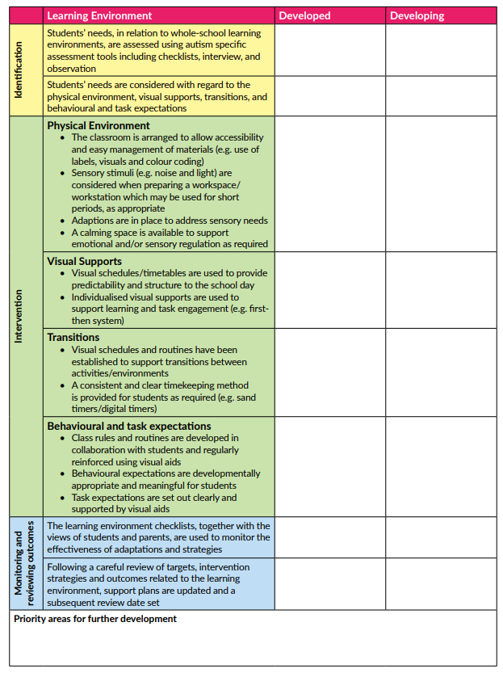

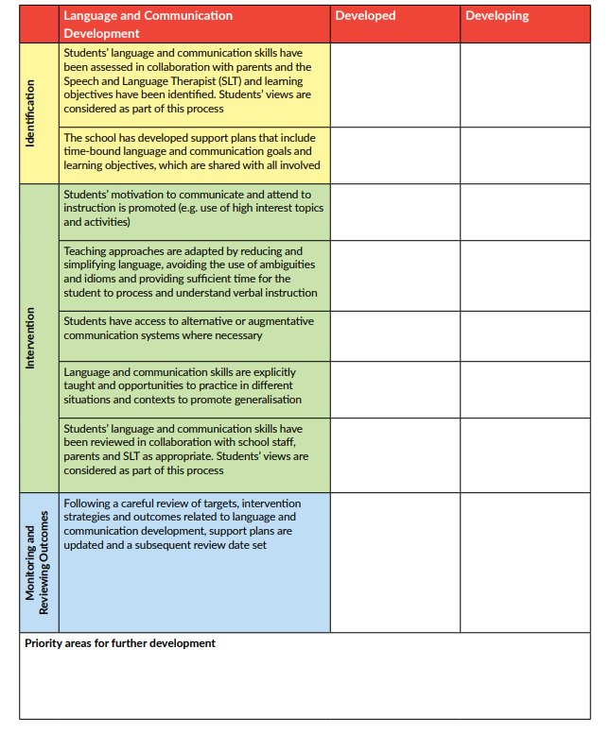

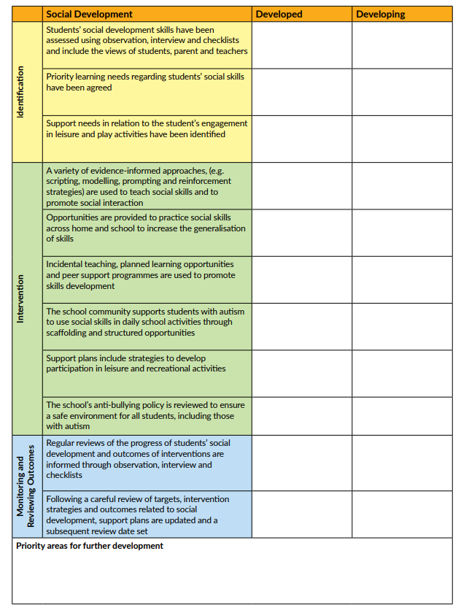

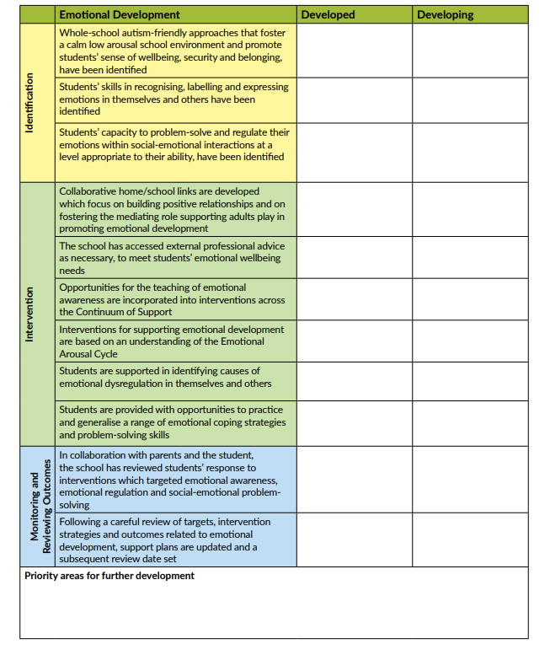

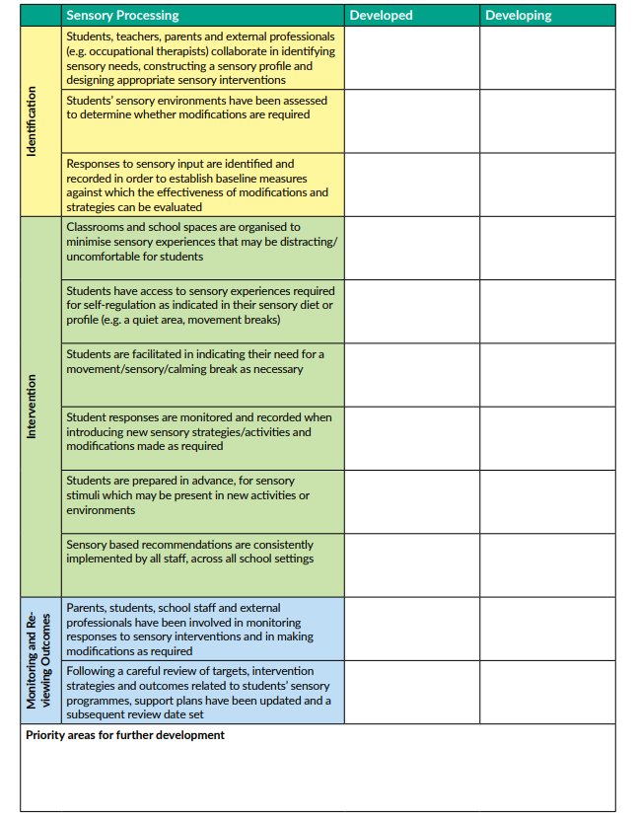

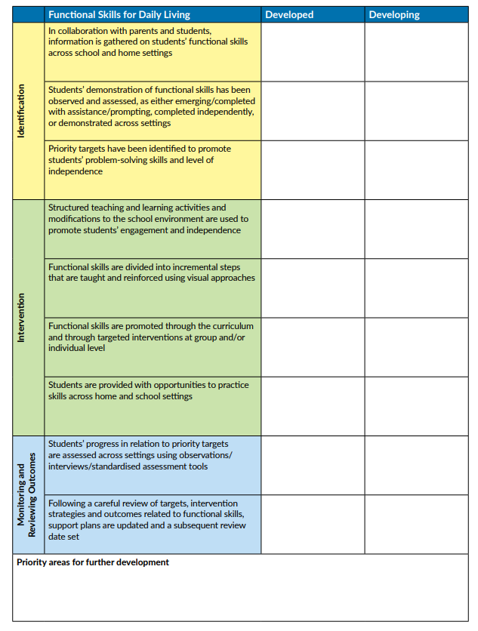

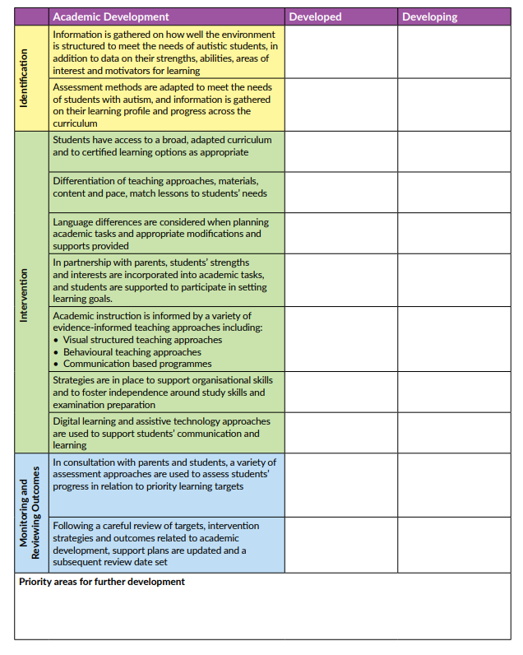

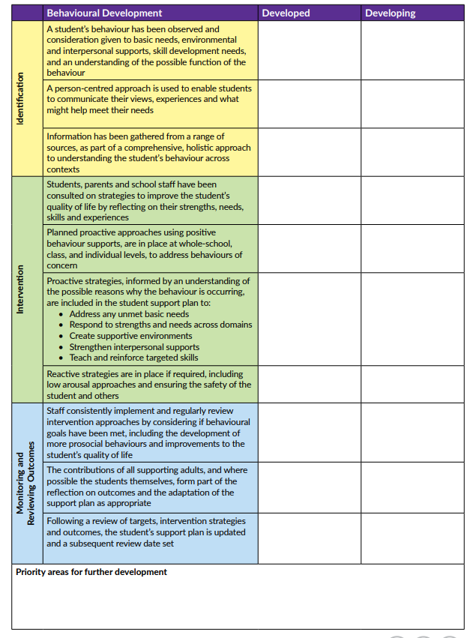

Appendix B

Monthly Behaviour Checklist
Nature of Difficulty | Yes/No | If yes what extra provisions need to be put in place? | By whom? | Date/Time
Are there students with disabilities including physical disability, vision impairment, hearing impairment, intellectual disability or mental health condition?
Are there students whose first language is not English and who may require extra focus with respect to safety, health and welfare?
Are there students with challenging behaviour that could increase the potential for injury to occur?
What instances of challenging behaviour have occurred this past month?
Are any children a flight risk?

Signed: ______________________________

Appendix C
Behaviour Plan
Name:
Behaviour(s) | Trigger if any | Preventative Strategies in place | By whom? | Consequence for action

Signed: _______________________________________

Appendix D
Extreme Behaviour Plan
Strengths/Interests | Extreme Behaviour Concerns
Triggers | Targets in Reducing Extreme Behaviour
Targets in Relation to Positive Behaviour | Strategies
Staff Involved | Success Measured By
Review Date | Reflection on Review
As noted in NCSE Policy Advice on Supporting Students with Autism Spectrum Disorder in Schools 2015
- ‘Restraint or seclusion should never be used except in situations where a child or young person poses imminent danger of serious physical harm to self or others, and should be avoided to the greatest extent possible without endangering students and staff.’
- ‘There is a duty of care to respond to prevent serious injury arising from harmful and/or dangerous behaviour’
- ‘Seclusion/restraint is never used as a sanction or punishment, but only to protect children/young people from immediate risk of injury to self or others or serious damage to property.’
- ‘The only legitimate rationale for the use of seclusion and/or restraint is when it is used in an emergency situation, to prevent injury or harm to the student concerned or to other students or staff.’

Appendix E
Intimate Care Needs Plan

Plan
Name
Date of Birth
Class
Relevant Staff
Nature of Care
Time/Frequency Each Day
Provision for Absent Staff
Equipment Required
Provisions for Equipment Use
Procedures for Storing/Disposing Materials
Language to be Used | Naming body parts: Vagina; Penis; Bottom  Naming bodily functions: Urination; Bowel movement
Cultural/Religious Sensitivities
Plan Team
Parent 1
Parent 2
Special Class Teacher
SNA 1
SNA 2
Principal

Appendix F
Incident Report Sheet
Date of Incident
Time of Incident
Child Involved
Teacher/SNA Involved
Description of Incident
Were Parents contacted and how?
Was Medical Treatment necessary?

