St Oliver Plunkett’s Primary School
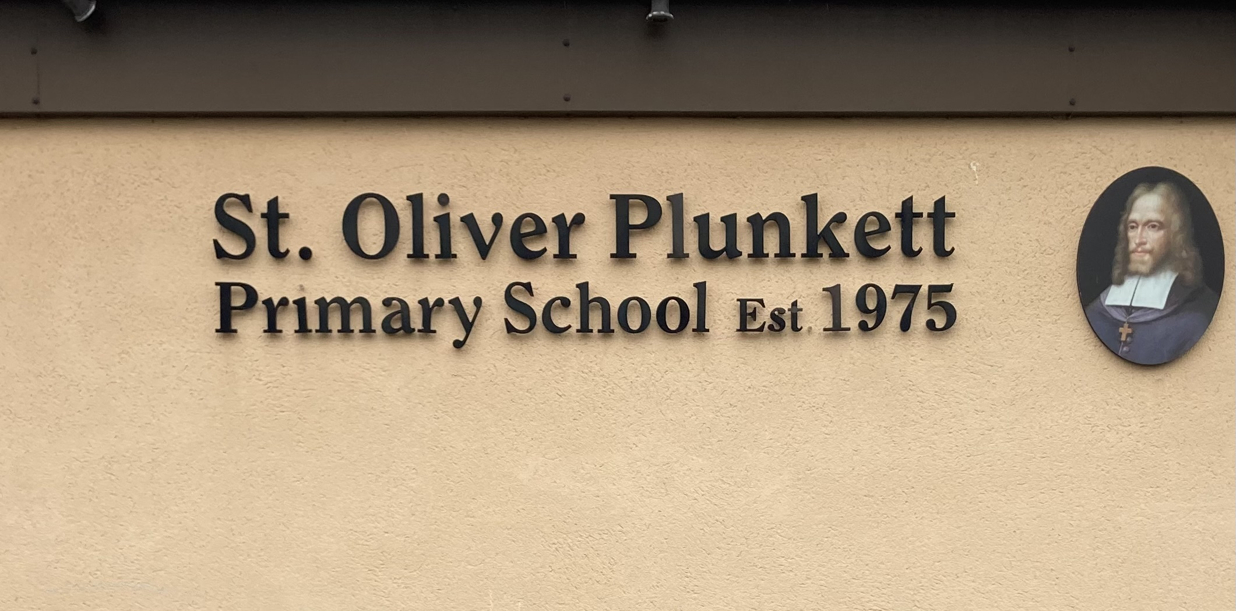
Blackcastle, Navan, Co Meath
Roll number: 19476h
www.stoliverplunkettsnavan.ie
Twitter: @st_navan
Email: stoliverns2@gmail.com
School Patron/s: Bishop of Meath

EAL Policy

Introductory Statement
The purpose of this policy is to provide guidelines to school staff on the delivery of English as an additional language in St. Oliver Plunkett Primary School. This policy will provide a basis of consistency and quality while allowing for flexibility in the delivery of EAL service. The aim of our EAL policy is to ensure that pupils develop the competence to use English confidently as a means of learning across the range of curriculum areas. St Oliver Plunkett P.S. acknowledges the right of children to communicate and socialise in the language of their home. The variety and diversity of the languages that the children bring to the classroom and to the school yard is respected and celebrated.

Rationale
We, in St Oliver Plunkett P.S., promote and facilitate the inclusion of all pupils in our school. We acknowledge our pupils’ diverse cultural backgrounds and languages. We strive to enable pupils, whose primary language and language at home is other than English, to develop their individual potential, both socially and academically, within the school system. We endeavour to support our pupils in developing their individual voice within the school context.

Aims and Objectives:
In St Oliver Plunkett P.S. we are committed to providing appropriate provision of teaching and resources for pupils for whom English is an additional language and for raising the achievement of all pupils. The aim of our EAL provision will be to successfully bridge any gap in fluency of English between children for whom English is the language of communication in all spheres of their life and those children for whom English is simply one of the languages of communication in their lives.
- The aim of the school’s EAL programme is the development of oral, reading and writing English language competency for identified children, to a standard that is comparable to that of children for whom English is their sole language of communication and in keeping with the capability of the child.

- In addition to this primary aim, the school also aims to facilitate the child in English language competence to assist in his/her integration into the life of the school and the English language community of his/her locality. The school recognises the importance of developing home-school links in this regard. The HSCL teacher will be of great benefit in this regard.

- It is also expected to develop the child’s sense of self-esteem and to encourage creativity in the child, which allows them to actively engage with the curriculum. This is contributed to by the day to day interactions with the children and their inclusion in initiatives such as Science Club, Chess Club, Sacramental Preparations, school trips and involvement in sporting teams.

Role of the Language Support Teacher
- The primary role of the EAL teacher is to promote the pupil’s development of English language proficiency so that he or she can gradually gain access to the curriculum. The pupil remains the responsibility of the mainstream class teacher who will work closely with the EAL teacher.
- In collaboration with parents and class teachers, the language support teacher will identify pupils requiring additional support, administer the assessment materials developed by Integrate Ireland Language and Training, devise appropriate language programmes, deliver the programmes and record and monitor pupils’ progress. (D.E.S. Circular 0053/2007)
- Language support teachers prepare the pupil on an ongoing basis to access mainstream learning and to socialise with peers; help the pupil to develop appropriate strategies and skills to support formal education.
- The language support teacher has access to the long-term English schemes of all classes. There is shared access to the Student Support File between the language support teacher and the class teacher through the school’s Aladdin system. Class and language support teachers meet on a formal and informal basis to discuss how the pupil is coping in class and interacting with peers.
- In St Oliver’s, EAL teachers and SET teachers work together as part of a Support Team. Support teachers are assigned to individual classes and to withdrawal groups based on the level of need across the whole school and there are regular meetings with the SENCO reviewing the Continuum of Support and ensuring the needs of the individual children are being met. The SET team work with and have shared responsibility with the EAL teacher in the area of testing.

- In collaboration with parents, the mainstream class teacher & the SET team the Support/EAL teacher
- Identifies pupils requiring additional language support.
- Assesses the pupils proficiency in English using the assessments tasks from the Up and Away programme and supplementary teacher-designed tasks/assessments.
- Devises an appropriate language programme (either in –class or withdrawal).
- Delivers the programme.
- Records and monitors the pupil's progress

Identification of pupils requiring Language Support
- The EAL/HSCL teacher will speak with the parents with regard to the languages of communication used in their family and community. An identification of the dominant or frequent use of another language other than English means that this child will be identified as having EAL needs.
- The class teacher will place the child on Classroom Support and over the first month of school term pay particular attention to the child to make a formal and informal assessment of the child’s English language capabilities and competencies. The checklist in the Classroom Support file with be useful in this regard
- The SET/EAL teacher will administer a selection of assessment from the Up and Away programme including an initial interview assessment for new pupils with interpretation based on the language proficiency benchmarks (Up and Away page 21) and teacher-designed tasks to ascertain the pupil’s level of proficiency using the English language.

Organisation of Language Support
- Language support pupils are assessed regarding their level of proficiency in the English language.
- In accordance with Circular 15/2009, pupils who meet the criteria for EAL will receive support for his/her first two years in the Irish school system. After a pupil has received two years of EAL support, additional support may be provided. This level of support is dependent on the availability of staff in the school and an annual evaluation of all the needs across the school.

- EAL support in St. Oliver Plunkett Primary School comprises of a mix of in-class support and pupil withdrawal by a teacher from the support team and this is determined by strategies that will best meet the needs of the pupils. Allocation of additional support for pupils who require language support for more than two years is considered with reference to DES Circular 0015/2009.

- In the Infant classrooms, in-class activities will be sophisticated English language activities based on the Infant Primary Curriculum. In the Junior and Senior Infant classes, the Support/EAL teacher will provide support in the classroom where appropriate and possible.

- The language support teacher, in collaboration with the class teachers, arranges a timetable for pupils to receive language support, to ensure all qualifying children are receiving language support.

- Flexibility in the delivery of language support is required and various models of support are delivered, depending on the child's age, class and learning requirements.

- The class teacher will keep the language support teacher informed about how the pupil is progressing in the class and coping with interaction with peers.

- Standardised testing: In reference to Circular 0138/2006: “Pupils may be excluded from the test if in the view of the school principal they have a learning or physical disability which would prevent them from attempting the test, or in the case of newcomer pupils where their level of English is such that attempting such a test would be inappropriate.” It is generally accepted that pupils who have not reached level A1.3 of the Language proficiency benchmarks may not be tested with standardised tests.

Programme Planning
Programme Planning will involve the following steps
- Identifying EAL learners
- Aiding the 'settling down' period
- Collaboration between class teacher and Support/EAL teacher
- Initial assessment
- Devising a specific language programme for individual pupils/groups
- Delivering language programme
- End of year assessment/progress assessment carried out by SET team (Primary School Assessment Kit, Aistear record sheet )
The EAL curriculum is divided into 13 units of work.

1. Myself
2. Our School
3. Food and Clothes
4. Colours, Shapes and Opposites
5. People Who Help Us
6. Weather
7. Transport and Travel
8. Seasons, Holidays and Festivals
9. The Local and Wider Community
10. Time
11. People and Places in Other Areas
12. Animals and Plants
13. Caring for My Locality

Recording and Monitoring of Pupil’s Progress
The EAL teacher will record and monitor pupils progress by:
- Initial assessment ( Up and away programme, Aistear programme and teacher designed tasks)
- Teacher observations
- Teacher questioning
- Pupils work samples
- Meeting with class teacher to discuss progress both in the language support class and in the mainstream class.
- End of year assessment/ progress assessment carried out by SET team(Primary School Assessment Kit and/or Aistear checklists)

Individual Teacher Planning and Reporting
- The EAL teacher will keep a file for every pupil detailing work planned, work completed and all test results
- Every EAL pupil will have a Student Support File.
- Class Teachers and the language support teacher meet on a formal and informal basis to discuss how the pupil is coping in class and interacting with peers.
- Class teachers and the language support teacher discuss and agree on suitable homework for EAL pupils.
- SENCO, EAL teachers and SET teachers meet to discuss the progress of EAL students

Success Criteria
The following criteria will indicate that the scheme has been successful:

- EAL pupils will improve their acquisition and use of the English language.

- All pupils will be fully integrated in to life of the school and participate in all activities

- Teacher evaluation and assessment.

- Feedback from school principal, teaching staff, SNAs, parents, DES inspectors
- In accordance with D.E.S. guidelines, pupils will be deemed to have succeeded in English language when they have reached B1.3 level in the four language proficiency skills.

Roles and Responsibilities
- The policy is coordinated by the SEN Coordinator.
- The SEN Coordinator and school principal will monitor implementation of the plan.
- All teachers will be responsible for implementation of the policy.
- The EAL pupil remains the responsibility of the mainstream class teacher.
- The primary responsibility of the language support teacher is to promote the pupil’s development of English language proficiency so that she can gradually gain access to the curriculum
This policy was reviewed in January 2024 by
- Aisling Tunney & Ciara Ginnitty (EAL Teachers)
- Nigel Ryan (Acting- SENCO)
- Padraig Farrell (Principal)

Next Date of Review: January 2026

Appendix 1
Initial Interview from Up and Away
