**St Oliver Plunkett’s Primary School**

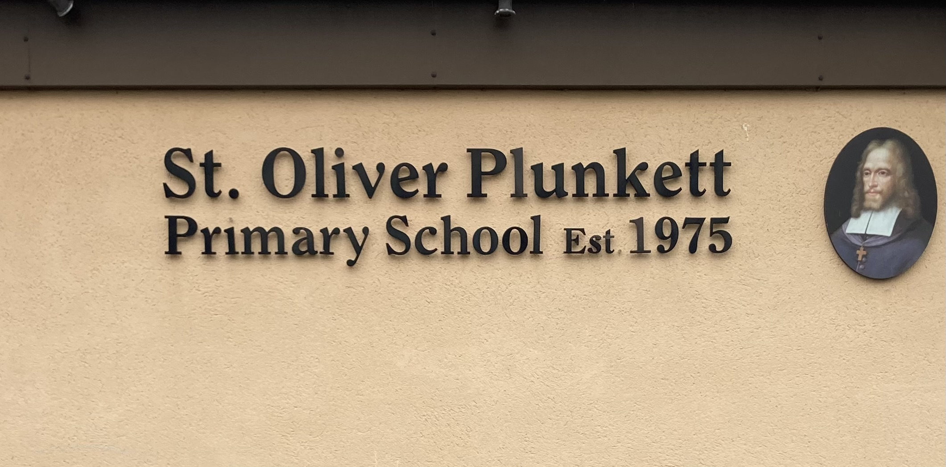

**Blackcastle, Navan, Co Meath**

**Roll number: 19476h**

[**www.stoliverplunkettsnavan.ie**](http://www.stoliverplunkettsnavan.ie)

**Twitter: @st_navan**

**Email:** [**stoliverns2@gmail.com**](mailto:stoliverns2@gmail.com)

**School Patron/s: Bishop of Meath**

**Intimate Care Policy**

**Introduction**

Intimate care is any caring procedure which involves attending to a student when he/she is undressed or partially dressed, washing (including intimate parts), helping to use the toilet, changing nappies or carrying out a procedure that requires direct or indirect contact with an intimate area of a student, or any procedure carried out while the student is in a state of whole or partial undress. The supervision of students while they are dressing and undressing will also be considered as intimate care. This policy and related procedures have been developed bearing in mind that all physical contact between staff and students:

• Should be aimed at meeting the needs of students

• Should respect the dignity of each student

• Should be consistent with professional integrity of staff members

**Policy Rationale**

The aim of the policy is to increase knowledge, enhance skills and promote good practice in this sensitive area. All staff will be made aware of the standards expected of them. Intimate care will be carried out only by regular school employees.

**Relationship to the School Ethos**

All students and staff members have the right to feel safe and be treated with dignity and respect

**Aims and Objectives**

The aims of this policy are;

• To ensure that the dignity and privacy of the student involved is paramount

• To develop a framework of procedures whereby intimate care requirements are dealt with in an appropriate manner.

**Staffing Levels**

*Toileting ‘Accidents’*

As teachers we act ‘in loco parentis’ and can deal with a toileting accident without assistance. It is good practice to only provide help that is required by the student. The teacher should encourage the student to do as much for themselves as possible. If the pupil has soiled him/herself, the parents will be contacted in order to take the pupil home. In the event that a parent cannot be contacted, the teacher/SNA will do all that is necessary to make the pupil comfortable. Wet/soiled clothes will be put in a plastic bag and parents will be informed of what has happened when they collect their child. Parents are asked to return the clothes given to their child, washed and folded. A record of such incidents will be kept by the class teacher. Parents are informed on this procedure in the Junior Infants Induction meeting prior to their pupil starting school. Changes of clothes and underwear are kept in the HSCL Room (Room 25). Staff are required to wear protective gloves while changing a pupil.

*Toileting of students in the ASD Classes*

It is school policy that;

• The personnel involved in intimate care needs of students are usually SNA’s but teachers may be involved.

• There should be a minimum of two staff members present at all times. Additional support will be provided by mainstream SNA’s if needed.

• No substitute SNA should be involved in the toileting of a student unless sanctioned by the Principal or the SENCO

***Parent Responsibilities***

Parents/Guardians need to identify any toileting needs in their application form. They should supply the school with the resources required to carry out the toileting or other care needs, which may include, but not be limited to;

* Nappies
* Wipes
* Creams
* Nappy Sacks
* Spare underwear
* Spare Clothes
* Sanitary Pads

**Sanitary Towels**

There is an adequate supply of sanitary bins in appropriate classroom toilets. This will be kept under review and updated by school management as necessary. Spare towels will be kept in classrooms as necessary.

Mainstream classes: Senior classes will be taught about menstrual periods as part of the RSE programme (with parental consent). They will also be informed about where they can get a sanitary towel if they need it. SEN Classes: Senior classes will be taught about periods as part of the RSE programme (with parental consent). They will also be informed about where they can get a sanitary towel if they need it (class teacher or SNA). Measures will be taken on a case by case basis, according to the level of support needed by individual pupils. Strategies may include:

* RSE lessons (with parental consent)

A private and discreet space for training will be provided. Teachers will liaise with home re. progress and practice and support at home. With parental consent, pupils will be supported if necessary in the following ways:

* Reminders to change sanitary towel
* Discreet verbal support/prompting from outside toilet door

Intimate Care/Toileting Plan

In the event that a specific toileting need has been identified for a pupil, an Intimate Care/Toileting Plan will be developed in partnership with the pupil’s class teacher, designated SNA’s and the pupil’s parents/guardians. The Care Plan may include:

* Specific care need
* Number of staff required to meet the needs of the pupil
* Identification of the staff members involved
* Additional equipment required 4
* Pupil’s preferred means of communication to include agreed terminology for body parts and bodily functions.
* Pupil’s level of ability
* Cultural and/or religious sensitivities
* Signature of Class Teacher
* Signature of Principal
* Date of Care Plan

**Elements of Good Practice for Staff**

While it is not possible to prescribe guidelines that will apply in all situations, it is important the elements of good practice be followed:

* In the case that a pupil has an Intimate Care Plan, relevant staff must be completely familiar with the plan
* Ensure the child is happy with who is changing him/ her
* Be responsive to any distress shown
* Staff will address the pupil by name and ensure he/she is aware of the focus of the activity
* Staff will verbalise their actions to the pupil in a reassuring way to prepare them for each procedure.
* For pupils with limited communication, staff will use visual supports e.g. pointing at a wipe or picture board
* Appropriate and professional language will be used. Specific language may be detailed in a care plan.
* In intimate care, the touch should be affirmative and supportive, not rough or insensitive
* Dignity and privacy of the pupil will be respected at all times
* Staff will have all equipment and materials to hand before commencing. • Staff will use discreet observation to check if a nappy/pad needs changing
* Staff will use protective gloves provided
* All precautions will be taken when disposing of soiled material in the bin provided
* Intimate care procedures will be carried out in a manner which treats the pupils in a dignified and respectful way and allows the pupil the maximum level of privacy
* The pupil’s independence will be encouraged.

**Providing comfort or support to a child**

There are situations and circumstances where children seek physical comfort from staff (particularly in early years). Where this happens staff need to be aware that any physical contact must be kept to a minimum. When comforting a child or giving reassurance, staff must ensure that at no time can the act be considered intimate. If physical contact is deemed to be appropriate, staff must provide care which is professionally appropriate to the age and context. If a child touches a member of staff in a way that makes him/ her feel uncomfortable this can be gently but firmly discouraged in a way which communicates that the touch, rather than the child, is unacceptable. If a child touches a member of staff, as noted above, this 5 should be discussed, in confidence, with the DLP (Padraig Farrell) or DDLP (Kathleen Quinn).

**Swimming**

Throughout the year the classes of St Oliver Plunkett Primary School participate in swimming lessons in Aura Leisure Centre Navan. Children are entitled to respect and privacy when changing their clothes. However, there must be the required level of supervision to safeguard young people with regard to health and safety considerations and to ensure that bullying, teasing or other unacceptable behaviour does not occur. Where a child needs additional support for changing, parental permission will be sought and a personal care plan will be drawn up so as to maintain dignity but increase independence.

**Showering**

Children are entitled to respect and privacy when changing their clothes or taking a shower. However, there must be the required level of supervision to safeguard young people with regard to health and safety considerations and to ensure that bullying, teasing or other unacceptable behaviour does not occur. This means that staff should announce their intention of entering changing rooms, avoid remaining in changing rooms unless pupil needs require it, avoid any physical contact when children are in a state of undress and avoid any visually intrusive behaviour. Given the vulnerabilities of the situation, it is strongly recommended that when supervising children in a state of undress, another member of staff is present. However, this may not always be possible and therefore staff need to be vigilant about their own conduct. It is best practice in our school that when an incident has taken place that has necessitated a member of staff to be present when young children are changing that an incident report is made.

**Reporting**

All toileting “accidents” involving pupils with no Care Plan must be reported to the pupils’ parents. If during the intimate care of a pupil;

* a staff member accidentally hurts/injures the pupil
* observes something which raises pupil protection concerns
* the pupil seems to misinterpret what is said or done
* the pupil has an emotional reaction without apparent cause the incident must be reported to the Special Class Teacher/Principal or the DLP or Deputy DLP as appropriate.

**Communication with children**

It is the responsibility of all staff caring for a child to ensure that they are aware of the child’s method and level of communication. Depending on their maturity and level of stress children may communicate using different methods- words, signs, symbols, body movements, eye pointing etc. To ensure effective communication:

* Make eye contact at the child’s level
* Use simple language and repeat if necessary
* Wait for response
* Continue to explain to the child what is happening even if there is no response
* Treat the child as an individual with dignity and respect

**Staff Roles and Responsibilities**

Teachers and school management assume shared responsibility, participate in and contribute to the implementation of an effective and equitable Intimate Care and Toileting Policy. All members of staff working with children must undertake the full Garda Vetting Procedure. This includes students on work placement and volunteers who may be left alone with children. Vetting includes criminal record checks and two references. Only those members of staff who are familiar with the Intimate Care and Toileting Policy are involved with the intimate care of children. Where anticipated, intimate care arrangements are agreed between the school and parents and, when appropriate and possible, by the child. Consent forms are signed by the parent and stored in the child’s file. Only in emergency situations would staff undertake any aspect of intimate care that has not been agreed by parents and the school. Parents would then be contacted immediately. The views of all relevant parties should be sought and considered to inform future arrangements. 7 If a staff member has concerns about a colleague’s intimate care practice s/he must report this to the DLP (Padraig Farrell) or DDLP (Kathleen Quinn).

**Success Criteria**

The school evaluates the success of the policy through:

1. Participation of all staff in the policy

2. Safe and effective care of all pupils in our school

3. Feedback from all staff 4. Feedback from relevant parents/guardians

**Ratification and Implementation**

This policy was ratified by the Board of Management on _________

**Review**

It will be reviewed every three years, with next review due in ________

Signed: Helena Gibbons

__________________________________

Date: (Chairperson Board of Management)

**Appendix 1**

**Letter of Permission from parents for Intimate Care**

Should it be necessary,

I give permission for ________________________________ to receive intimate care (e.g. help with changing or toileting, showering and grooming).

I understand that staff will endeavour to encourage our child to be independent.

I understand that I will be informed by the class teacher in advance of showering should any occasion arise in the school whereby my child needs assistance with toileting or cleaning of an intimate nature.

I understand that there will be two staff present at all times, where possible. I understand that the ultimate aim is to enable our child to be more independent.

Signed:_____________________________(Parent 1)

Date:_____________

**Appendix 2**

**Record of Intimate Care**

|  |  |  |  |  |
| --- | --- | --- | --- | --- |
| **Name of Child** | **Date** | **Time** | **Comments** | **Signature** |
|  |  |  |  |  |
|  |  |  |  |  |
|  |  |  |  |  |
|  |  |  |  |  |
|  |  |  |  |  |
|  |  |  |  |  |
|  |  |  |  |  |