St Oliver Plunkett’s Primary School
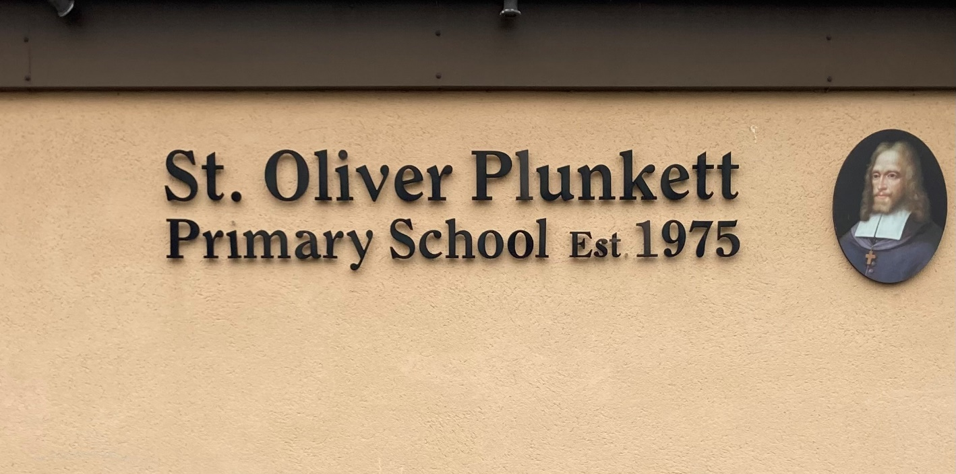
Blackcastle, Navan, Co Meath
Roll number: 19476h
www.stoliverplunkettsnavan.ie
Twitter: @st_navan
Email: stoliverns2@gmail.com
School Patron/s: Bishop of Meath

Critical Incident Policy

Introduction

St. Oliver Plunkett`s Primary School aims to protect the well-being of its pupils and staff by providing a safe and nurturing environment at all times. We endeavour to enhance the self-esteem of everyone in the school community, offering equal opportunities for all pupils to develop to their full potential in a well ordered and disciplined atmosphere where parental involvement is encouraged and the wider community is served.

The Board of Management, through the principal and staff, has drawn up a critical incident
management plan as one element of the school`s policies and plans. Our aim is to establish a Critical Incident Management Team (C.I.M.T) to steer the development and implementation of the Critical Incident Management Plan.

Definition of a Critical Incident

The staff and management of St Oliver`s School recognise a critical incident to be “an incident or sequence of events that overwhelms the normal coping mechanism of the school”. Critical incidents may involve one or more students or staff members, or members of our local community.
Types of incidents may include:

● The death of a member of the school community through accident, violence, suicide or suspected suicide or other unexpected death.
● An intrusion into the school.
● An accident involving members of the school community
● A major accident/tragedy in the wider community
● Serious damage to the school building through fire, flood, vandalism, etc
● A major accident/tragedy in the wider community.
● A physical assault on a pupil or staff member.
● The disappearance of a member of the school community.
● Unexpected evacuation of the school. (e.g. bomb threat)
● Unauthorised removal of pupil from school or home.
● Closure of the school because of infectious diseases.
● Civil unrest, war

Aims

The aim of the CIMP is to help school management and staff to react quickly and effectively in the event of an incident, to enable us to maintain a sense of control and to ensure that appropriate support is offered to students and staff. Having a good plan should also help ensure that the impact on students and staff will be limited. It should enable us to effect a return to normality as soon as possible.

Creation of a coping supportive and caring ethos in the school

We have put systems in place to help to build resilience in both staff and students, thus preparing them to cope with a range of life events. These include measures to address both the physical and psychological safety of the school community.

Physical Safety:

The following policies and strategies have been put in place in order to maintain the physical safety of all members of the school community.

- Health and safety statement for the school.
- Regular fire drills and evacuation procedures.
- Regular checking of fire exits and extinguishers.
- Yard gates kept closed during yard times.
- School yard rules and Code of Behaviour in place and regularly discussed with children.
- Pre-opening supervision in the school yard from 8.45 am- 9.00am
- Daily Supervision on Junior, Middle and Senior yard
- Sign-out procedures for pupils
- Sign-in/Sign-out Procedures for Staff
- Updated contact details for staff, and contact number in case of emergency for all staff (Aladdin)
- Updated contact details for parents/guardians (Aladdin)
- Record of pupils who may have specific medical needs (Aladdin)

Psychological Safety:

A number of policies and strategies also support the psychological safety of the pupils and staff.

● Social, Personal and Health Education (SPHE) is integrated into the work of the school. Issues such as grief and loss; communication skills; stress and anger management; resilience; conflict management; problem solving; help-seeking; bullying; decision making and prevention of alcohol and drug misuse are addressed in the SPHE curriculum. Promotion of mental health is an integral part of this provision
● Stay Safe, Walk Tall, Friends for life, Fun Friends, Zippy`s Friends are all taught in St Oliver`s school
● Staff have access to training for their role in SPHE
● Staff are familiar with the Child Protection Procedures and the names of the Designated Liaison Person (DLP) and the Deputy Designated Liaison Person (Deputy DLP)
● Books and resources on difficulties affecting the primary school student are available e.g. Friends for Life books available on self-esteem, resilience and problem solving.
● Information is provided on mental health in general and such specific areas as signs and symptoms of depression and anxiety (Friends for Life)

● Staff are informed in the area of suicide awareness and some have attended specialist training such as ASIST provided by the HSE
● The school has developed links with a range of external agencies eg. Education Welfare Officer, Navan School Completion, Navan Spring Board, NYPD, INTO, NEPS, TUSLA
● The school has a clear anti-bullying policy and deals with incidents of bullying in accordance with this policy

● Care Team meetings for vulnerable students take place once a month or more often if necessary.
● Students who are identified as being at risk are referred to the designated staff member (e.g. HSCL teacher), concerns are explored and the appropriate level of assistance and support is provided. Parents/guardians are informed, and where appropriate, a referral is made to an appropriate agency (a summary of this support is set out in R 23)
● Staff are informed about how to access support for themselves through EAS (Employee Assistance Service)
● Staff have completed `Introduction to Children First` programme 10th November 2022
● All staff have a copy of the Anti- Bullying Policy, Child Protection Policy and the Child Safeguarding Statement
● Don`t Be Mean Behind The Screen – Talk on cyber bullying given to 6th class each year( social media resilience)

Critical Incident Management Team (CIMT)

A CIMT has been established in line with best practice. The members of the team were selected on a voluntary basis and will retain their roles for at least one school year. The members of the team will meet annually to review and update the policy and plan. Each member of the team has a dedicated critical incident folder. This contains a copy of the policy and plan and materials particular to their role, to be used in the event of an incident.

Critical Incident Management Team

Team Leader: Pádraig Farrell, Acting Principal
Staff Liaison: Kathleen Quinn, Acting Deputy Principal
Student Liaison: Class Teacher, Marie Flood, Nigel Ryan
Community /Agency Liaison: Ruth Dunne, Anthony McDonagh and Leanne O`Donnell
Parent/Family Liaison: Ruth Dunne, Anthony McDonagh and Leanne O`Donnell
Media Liaison/Communication: Pádraig Farrell
Chaplaincy Role: Fr Noel Weir
Administrative Tasks: Bridget Mc Donagh, Kim O`Hare, Secretary

.

Roles and Responsibilities of the Team

Leadership Role- Team Leader

● Alerts the team members to the crisis and convenes a meeting
● Co-ordinates the tasks of the team
● Liaises with the Board of Management; DES; NEPS; SEC, ETB
● Liaises with the bereaved family.
● Liaises with the Gardaí
● Ensures that information about deaths or other developments is checked out for accuracy before being shared.

Staff Liaison

● Leads briefing meetings for staff on the facts as known, gives staff members an opportunity to express their feelings and ask questions, outlines the routine for the day
● Advises staff on the procedures for identification of vulnerable students
● Provides materials for staff (from their critical incident folder – `Ready to Go pack`)
● Keeps staff updated as the day progresses
● Is alert to vulnerable staff members and makes contact with them individually
● Advises them of the availability of the EAS and gives them the contact number

Student Liaison

● Alerts other staff to vulnerable students (appropriately)
● Provides materials for students (from their critical incident folder)
● Maintains student contact records (R1)
● Looks after setting up and supervision of ‘quiet’ room where agreed.

Community/ Agency Liaison

● Maintains up to date lists of contact numbers of
Key parents, such as members of the Parents Council
Emergency support services and other external contacts and resources
● Liaises with agencies in the community for support and onward referral
● Is alert to the need to check credentials of individuals offering support
● Coordinates the involvement of these agencies
● Reminds agency staff to wear name badges
● Updates team members on the involvement of external agencies.

Parent/Family Liaison

● Visits the bereaved family with the team leader, Arranges meetings, if held
● May facilitate such meetings, and manage ‘questions and answers’ sessions
● Manages the ‘consent’ issues in accordance with agreed school policy
● Ensures that sample letters are prepared and available on the school’s IT system ready for adaptation
● Sets up room for meetings with parents
● Maintains a record of parents seen
● Meets with individual parents
● Provides appropriate materials for parents (from their critical incident folder)

Communication Role- Media Liaison

● In advance of an incident, will consider issues that may arise and how they might be responded to (e.g. students being interviewed, photographers on the premises, etc.)
● In the event of an incident, will liaise where necessary with the SEC, relevant teacher unions etc.
● Will draw up a press statement, give media briefings and interviews (as agreed by school management).

Chaplaincy Role
● Visit home(s), if appropriate.
● Visit Classroom (s) to provide support, if appropriate.
● Lead prayer services if required.
● Be available as personal and spiritual support to staff.
● Work in partnership with the Critical Incident team.
● Make contact with other local clergy

Administrative Tasks

● Maintain up to date lists of staff, staff next of kin and pupils.
● General administrative tasks e.g. phone calls, typing, letters etc.
● Assist with recording and record keeping.

Media Briefing/Communication

As necessary, the Principal / Chairperson will prepare a brief media statement to include the following;

● Expressing sympathy for the affected /bereaved family.
● Stating that it is a difficult time for the school community.
● Positive information or comments about the deceased/ injured parties.
● The facts about the situation (following consultation with the families.)
● The term suicide will not be used; instead the term ‘tragic death’ will be used.
● Outline what is being done to support pupils and staff.

Record Keeping

In the event of an incident each member of the team will keep records of phone calls made and received, letters emails and texts sent and received, meetings held, persons met, interventions used, material used etc. The school secretary (Bridget Mc Donagh & Kim O`Hare) will have a key role in receiving and logging telephone calls, sending letters, photocopying materials etc.

Confidentiality and good name considerations

The management and staff of St Oliver Plunkett Primary School have a responsibility to protect the privacy and good name of the people involved in any incident and will be sensitive to the consequences of any public statements. The members of the school staff will bear this in mind, and will seek to ensure that students do so also. For instance, the term ‘suicide’ will not be used unless there is confirmed information that death was due to suicide, and that the family involved consents to its use. The phrases ‘tragic death’ or ‘sudden death’ may be used instead. Similarly, the word ‘murder’ should not be used until it is legally established that a murder was committed. The term ‘violent death’ may be used instead.

Critical Incident Room

● The Staff Room will be the main room used to meet the staff, students, parents and visitors involved.
● The school library will be used to accommodate a second group if needed.
● The PE hall will cater for a larger group if needed.

Short-Term Actions (Day 1)

● Gather accurate information-Who, What when, where?
● Convene a CIMT meeting
● Contact external agencies
● Arrange supervision for students
● Hold staff meetings
● Agree schedule for the day
● Inform students- (close friends and students with learning difficulties may need to be told separately
● Compile a list of vulnerable students
● Contact/visit the bereaved family
● Prepare and agree media statement and deal with the media
● Inform parents/guardians
● Hold end of day staff briefing

Medium Term Actions- (Day 2 and following days)

● Convene a CIMT meeting to review the events of day 1
● Meet external agencies
● Meet whole staff
● Arrange support for students, staff, parents/guardians
● Visit the injured
● Liaise with bereaved family regarding funeral arrangements
● Agree on attendance and participation at funeral service
● Make decisions about school closure

Follow-up Beyond 72 hours

● Monitior students for signs of continuing distress
● Liaise with agencies regarding referrals
● Plan for return of bereaved student(s)
● Plan for giving of `memory box` to bereaved family
● Decide on memorials and anniversaries
● Review response to incident and amend plan

Ratification and Review

This policy was reviewed on December 19th 2022 by Acting-Principal Padraig Farrell, Deputy Principal Kathleen Quinn, Ruth Dunne, Nigel Ryan, Marie Flood, Mary Reilly & Leanne O’ Donnell. It will be reviewed annually by the Critical Incident Team and brought to the Board of Management.

The policy will be disseminated annually to staff and will be available to all staff in the case of a critical incident.

Pádraig Farrell Helena Gibbons

(Acting Principal) (Chairperson, BoM)

Emergency Contact List

Agency | Contact Numbers
Garda | 046 9036100
Hospital | 046 9078564  046 9078500
Fire Brigade | 046 9051068
Local GP | Abbey Medical 046 9051500
HSE | 046 9021595
Community Care Team | TUSLA 046 9098560
Child & Family Centre | 046 9021595
CAMHS | 046 9079350
School Inspector | john_fitzgerald@education.gov.ie
NEPS Psychologist | 041 9876940
DES | 0906 6484150
INTO | 1850708708  01 8047700
Clergy | 046 9027518
Employee Assistance Service | 1800411057
Meath County Council | 046 9021881
Samaritans | 18500609090
Barnardos | 01 450355
Childline | 1800666666
Department of Education & Science | 01 8734700
ESB | 1850 372999

